**TURISTA APP**

**(TOURISM INFORMATION MOBILE APP)**

**A THESIS**

**PRESENTED TO THE FACULTY**

**OF THE GRADUATED SCHOOL**

**NEGROS ORIENTAL STATE UNIVERSITY**

**MAIN CAMPUS DUMAGUETE CITY**

**IN PARTIAL FULFILLMENT**

**OF THE REQUIREMENTS FOR THE DEGREE**

**MASTERS OF SCIENCE IN INFORMATION TECHNOLOGY**

**BY**

**RALPH JESSE ANTO**

## **APPROVAL SHEET**

In partial fulfillment of the requirements in Masters of Science in Information Technology. This research entitled: TURISTA MOBILE APP has been examined and is recommended for oral defense.

DR. ROCHE CABANLIT

MSIT ADVISER

This statistical research entitled **TURISTA MOBILE APP** prepared and submitted by **RALPH JESSE ANTO** has been reviewed and approved by DR. ROCHE CABANLIT.

Approved by Dr. Roche Cabanlit on 28th of March, 2018 with a rating of_________.

DR. ROCHE CABANLIT

DATE SIGNED: ________

Accepted as fulfillment of the requirements in Masters of Science in Information Technology. These are the panel members:

## **ACKNOWLEDGEMENT**

First and foremost, praises and thanks to our Dear God, the Almighty, for His great blessings throughout my research work successfully. My heartfelt and sincere gratitude to my research adviser, Roche L. Cabanlit for giving the opportunity to do and providing guidance throughout this research. Also, a big thanks to all the panelists who contributed their knowledge and support to make this program possible.

I am extremely grateful to my uncle who motivated and encourage me much in pursuing and giving his financial support to my Masteral program all throughout. Special thanks to my parents for their unending love and support for educating and preparing me for my good future. Also, thank you so much to my caring and loving uncles and aunties for sharing their wisdom on how to be persevere to reach the goal. And also, thank you to my cousins, relatives and friends for their kind words.

## **EXECUTIVE SUMMARY**

|  |  |  |  |
| --- | --- | --- | --- |
| **PROBLEMS** | **FINDINGS** | **CONCLUSIONS** | **RECOMMENDATIONS** |
| What are the existing tools used by tourists and locals in locating point of interest in Metro Dumaguete? | There are many existing tools used in navigating destinations in Metro Dumaguete. | It concludes that there are many locals/tourists cannot locate destinations or give an accurate location. | Possible solutions to create an accurate information about establishments given. |
| What are the problems encountered by the tourists and locals with the current navigation tools in locating point of interest within Metro Dumaguete? | Problems encountered to tourists can be a solution to communicate without barriers as long as it is accurate and understandable. | There are concrete solutions to communicate and understand their language to navigate and locate different destinations. | Evidences like different navigation map apps that will translates the information of a specific location/ destination. |
| How to design and develop of an effective Turista Mobile App in Metro Dumaguete? | By finding solutions to design and develop of an effective and accurate information details about an establishment. | By creating a mobile app that will gives accurate information about an establishment or even a destination. It also gives more details about history, culture and facts. | Possible evidences to design more mobile applications to navigate and give accurate information for more destinations. |
| What are the features of an effective Turista Mobile App in Metro Dumaguete? | By using different tools and features used in Turista App as the main app in Metro Dumaguete. | It concludes that the using of Turista Mobile App will be an accurate, effective and safe mobile app for locals and even tourists. | It recommends different features of  Turista Mobile App like History, Fun Facts, Gallery and many more features. |
| How to implement the Turista Mobile App in Metro Dumaguete? | The implementation of the mobile app finds the way to give an accurate and more secured information details about an establishment. | It concludes more implementation of the given mobile app and different features. | Possible implementation is to enhance more in creating and developing more navigation map apps to gives information to details. |

## **ABSTRACT**

Mobile devices are most present in our day-to-day activities such as become an important major factor in travel and leisure in destinations. This research study tackles on the tourism navigation and information to tourists in travelling and guiding in Metro Dumaguete using mobile phones.

The objective of the study is to understand the history and culture, facts, information of the different places and destinations in cities and even municipalities.

The aim of the study is to guide users’ particularly foreign tourists and local tourists to enhance on the travel experience and explore new tourists’ spots and destinations in the Metro Dumaguete. As the results reveals that travelers are increasingly shifting travel-related activities that were usually conducted through the number of foreign tourists and local tourists per month within the year.

## **LIST OF FIGURES**

|  |
| --- |
| **Figure 1:** THEORETICAL FRAMEWORK DIAGRAM 17  **Figure 2:** CONCEPTUAL FRAMEWORK DIAGRAM 18  **Figure 3:** MAP OF DUMAGUETE CITY 24  **Figure 4:** MAP OF MUNICIPALITY OF SIBULAN 24  **Figure 5**: MAP OF MUNICIPALITY OF BACONG 25  **Figure 6:** MAP OF MUNICIPALITY OF VALENCIA 25  **Figure 7:** TOTAL NUMBER OF TOURIST NATIONALITY IN DUMAGUETE CITY 27  **Figure 8:** TOTAL NUMBER OF TOURIST NATIONALITY IN MUNICIPALITY OF SIBULAN 27  **Figure 9:** TOTAL INFLUX OF TOURIST NATIONALITY IN MUNICIPALITY OF BACONG 28  **Figure 10:** TOTAL INFLUX OF TOURIST NATIONALITY IN MUNICIPALITY OF VALENCIA 28  **Figure 11:** TOTAL INFLUX OF DUMAGUETE CITY FOR 2019 29  **Figure 12:** INFLUX FOR TOURIST NATIONALITY FOR MUNICIPALITY OF SIBULAN (2019) 29  **Figure 13:** TOTAL INFLUX OF TOURIST NATIONALITY IN MUNICIPALITY OF BACONG 2019 30  **Figure 14:** TOTAL INFLUX FOR TOURIST NATIONALITY IN MUNICIPALITY OF VALENCIA 2019 31  **Figure 15:** TOTAL NUMBER OF TOURIST NATIONALITY 2018-2019 32  **Figure 16:** TOOLS USED FOR NAVIGATING DESTINATIONS IN METRO DUMAGUETE 35  **Figure 17:** PROBLEMS ENCOUNTERED TOURISTS WITH THE CURRENT NAVIGATION TOOLS USED 37  **Figure 18:** EFFECTIVENESS OF TURISTA APP IN METRO DUMAGUETE 38  **Figure 19:** FEATURES OF TURISTA APP 39  **Figure 20:** TOTAL INFLUX BY GENDER 40  **Figure 21:** FLOWCHART FOR USER REGISTRATION 45  **Figure 22:** ADMIN USER FLOWCHART 46  **Figure 23:** ENTITY RELATIONSHIP DIAGRAM 46  **Figure 24:** DATA FLOW DIAGRAM 47  **Figure 25:** LEVEL 1 CONTEXT FLOW DIAGRAM 48  **Figure 26:** CONTEXT FLOW DIAGRAM 48  **Figure 27:** USE CASE DIAGRAM 49  **Figure 28:** ACTIVITY DIAGRAM 50 |

## **LIST OF TABLES**

|  |
| --- |
| **Table 1:** TOOLS USED IN NAVIGATING DESTINATIONS IN METRO DUMAGUETE 36  **Table 2:** PROBLEMS ENCOUNTERED TOURISTS WITH CURRENT TOOLS USED 37  **Table 3:** TOTAL INFLUX FOR EFFECTIVENESS OF TURISTA APP 38  **Table 4:** FEATURES OF TURISTA APP 39  **Table 5:** MAIN SUCCESS SCENARIO 50 |

## **LIST OF APPENDICES**

|  |  |  |
| --- | --- | --- |
| **APPENDIX** | **TITLE** | **PAGE** |
| **A** | Letter of Request | **57** |
| **B** | Questionnaire for Turista Mobile App | **58** |
| **C** | Turista Mobile App Evaluation Criteria Assessment | **61** |
| **D** | Turista Mobile Application Testing Assessment | **70** |
| **E** | Turista Mobile App Manual Guide and its Features | **72** |
| **F** | Gantt Chart | **87** |
| **G** | Curriculum Vitae | **88** |

**TABLE OF CONTENTS**

APPROVAL SHEET ii

ACKNOWLEDGEMENT iii

EXECUTIVE SUMMARY iv

ABSTRACT vi

LIST OF FIGURES vii

LIST OF TABLES viii

LIST OF APPENDICES ix

**CHAPTER ONE: THE PROBLEM AND ITS SCOPE**

INTRODUCTION 13

STATEMENT OF THE PROBLEM 13

SIGNIFICANCE OF THE STUDY 14

SCOPE AND LIMITATIONS OF THE STUDY 16

OPERATIONAL DEFINITION OF TERMS 16

THEORETICAL FRAMEWORK OF THE STUDY 17

CONCEPTUAL FRAMEWORK OF THE STUDY 18

REVIEW OF RELATED LITERATURE AND STUDIES 19

RESEARCH METHODOLOGY 23

RESEARCH DESIGN 23

RESEARCH RESPONDENTS 24

RESEARCH ENVIRONMENT 24

RESEARCH INSTRUMENTS 33

DATA-GATHERING PROCEDURES 34

STATISTICAL TREATMENT OF DATA 34

**CHAPTER TWO: PRESENTATION, ANALYSIS AND INTERPRETATION OF DATA**

INTRODUCTION 36

EXISTING TOOLS USED IN NAVIGATING DESTINATIONS 36

PROBLEMS ENCOUNTERED BY TOURISTS IN LOCATING DESTINATIONS 37

THE EFFECTIVENESS OF TURISTA MOBILE APP IN METRO DUMAGUETE 39

FEATURES OF A MOBILE NAVIGATION TOURISM APP IN METRO DUMAGUETE 40

TOURISTS INFLUX BY GENDER 41

TOURIST INFLUX BY NATIONALITY 41

INFLUX OF TOURISTS BY PLACE OF ORIGIN 42

**CHAPTER THREE: ASPECTS OF AN EFFECTIVE TURISTA APP AND ITS GENERAL FEATURES**

INTRODUCTION 42

PURPOSE AND DESCRIPTION 43

ANDROID DEVELOPMENT SPECIFICATION 43

ANDROID PRODUCTIVITY PERSPECTIVE AND ITS GENERAL FEATURES 44

HARDWARE AND SOFTWARE REQUIREMENTS 45

TURISTA MODELS AND DIAGRAMS 46

FLOWCHART (TURISTA USER) 46

ADMIN USER FLOWCHART 47

ENTITY RELATIONSHIP DIAGRAM 47

DATA FLOW DIAGRAM 48

USE CASE SCENARIO AND USE CASE DIAGRAM 50

ACTIVITY DIAGRAM 51

TURISTA APP NON-FUNCTIONALITY REQUIREMENTS 52

**CHAPTER FOUR: RESTATEMENT OF THE PROBLEM, SUMMARY OF FINDINGS, RECOMMENDATIONS AND CONCLUSIONS**

INTRODUCTION 54

BRIEF RE-STATEMENT OF THE PROBLEM 54

SUMMARY OF FINDINGS 55

RECOMMENDATIONS 55

CONCLUSIONS 56

**SUPPLEMENTARY PAGES**

REFERENCES 56

APPENDICES 58

**CHAPTER ONE**

**THE PROBLEM AND ITS SCOPE**

# **INTRODUCTION**

Tourism today is the biggest industry on the planet as most people in general seek to travel for leisure and entertainment at one point in their lives. In the most recent decade, more innovations have been gaining rapidly, computers have become wider or even smaller, portable and even cheaper. These productive innovations have opened up in ways to enhance create other innovative ideas, re-create new ideas that will improve the tourism industry. In a traditional manner of exploring and searching tourist destinations or even establishments.

The aggregate number of android phones have been expanded and extended without end in years, since they have moved toward more becoming, compelling, secured and most especially being flexible and it turns out being more helpful in a regular daily basis. Android phones and other mobile devices that will be used for searching and viewing maps.

The Turista App, it is an all-in-one app that have different features and functions. It is consisting of: History, Fun Facts, Gallery and Tourism Information Portal. The History consists of one city and three municipalities: Dumaguete City, Municipality of Sibulan, Municipality of Bacong and the Municipality of Valencia. The Fun Facts consists of the different facts about food, place, books, people and many more. The Gallery, consists of photos and videos. Lastly, the Tourism Information Portal, wherein you can search and view certain establishments with their information details. Other features like Turista Profile and Turista Brochure wherein you can also download the brochure of the Turista App.

The Turista App is one of the easiest, very efficient, effective, flexible, more secured and protected. It is the most essential sort of mobile app in which the tourist or even locals can search and view information and destination or even new information about establishments. The researcher seeks to plan, create, analyze, and design layouts and to develop a new input and output of ideas in making the Turista App in Metro Dumaguete as one of my proposals. The main goal of this study is to contribute new ideas and concepts that will adapt for future use.

# **STATEMENT OF THE PROBLEM**

People travel for variety of reasons: to escape, explore, understand and even participate. But at the core of the experience lies the destination - the place that hands something to the traveler both locals and tourists to keep and share with others. Destination information and its point of interest is far less in some places like Dumaguete and other places. It needs a tool to assist the tourists in a very convenient way in searching and viewing a specific destination with the use of Turista App.

Specifically, it seeks to answer the following queries:

1. What are the existing navigation tools used by the locals or tourists in local point of interest?
2. What are the problems encountered by the locals or tourists with the current navigation tools used in locating points of interest within Dumaguete City?
3. How to design and developed an Effective Tourist Mobile App for android phones in Metro Dumaguete?
4. What are the features of an effective Tourist Mobile App for android phone users in Metro Dumaguete?
5. How to implement the Turista App for android phone users in Metro Dumaguete?

# **SIGNIFICANCE OF THE STUDY**

This study is of great significance to the Tourism Industry in Metro Dumaguete. The Turista App aims to benefit the following stakeholders or users as the result of this study:

**METRO DUMAGUETE**

It is the most significant part of the study. The tourist or even locals' users of Metro Dumaguete can search and view the different destinations, they can also view features of the Turista App. It is to improve the existing tools used in searching different destinations. The Turista Information Portal feature can be easily accessed by locals and tourists become popularly known locally and internationally.

**LOCALS AND TOURISTS**

The proposed Turista App for android users, the locals and tourists can search and view information for a specific destination/establishment/category. This study will guide the locals or even tourists to view information in an accurate and timely manner. Data gathered will also help and guide the locals and tourists to improve both navigation and information accuracy.

**TOURISM INDUSTRY**

The Tourism Industry is one of the major key factors of Metro Dumaguete. This would boost both social and economic status of Metro Dumaguete by providing an accurate information, more secured, more convenient and innovative type of application. Thus, it brings us world class both travel and leisure for locals and tourists in the tourism industry.

**ADMIN**

The admin will be part of the study, it consists of the following features that admin will be benefited: The admin will view and search the number of tourists, the tourist registered, the number for tourists' nationality, and list of establishments. The admin only can add an establishment per legend. Also, the admin can compute the number of tourists per month according to their gender and nationality both Filipino nationality and foreign nationality.

**FUTURE RESEARCHERS**

This study will also be helpful to future researchers with the research topic. This would provide relevant and distinctive information from the inputs and outputs of the study.

# **SCOPE AND LIMITATIONS OF THE STUDY**

The Turista App for android users in Metro Dumaguete, is an information-navigation portal wherein it can search and view the accurate information destination in Metro Dumaguete. The system scope of the study will be limited number of establishments per category. It only caters the admin to add new accurate establishments in terms of address and other information provided.

# **OPERATIONAL DEFINITION OF TERMS**

**ANDROID STUDIO**: It is a windows application that designed and developed for android mobile application with the use of layout designs using XML and supports Java or with the use of Kotlin as the built-in tools for creating android mobile apps.

**DATABASES**: It is a data or information where you can create, insert or delete a certain row or column within the table.

**MOBILE APPLICATION**: It is an application that runs and design by a mobile. In Turista Mobile App, it is designed and developed by an android application called Android Studio.

**TURISTA**: It is an android application for users to search and view information about a specific destination that will allow the users to give accurate information about establishments or even places.

**PHPMYADMIN**: It is a database application wherein you can create and insert a database name and table name that will connect/transfer to your mobile application.

**TOURISM INFORMATION PORTAL**: It is an information portal, wherein the users can search and view information of a certain establishment per category.

# **THEORETICAL FRAMEWORK OF THE STUDY**

The Theoretical Framework of the study outlines three major theories that will complement or supports with the Turista (Tourist Mobile Application) namely: Task Technology Fit Theory, Technology Acceptance Theory and Diffusion of Innovations Theory serves as the foundation of the study.

There are concepts or theories that will be fitted according to the study. It consists of task-technology fit theory, acceptance of technology theory and diffusions of innovation theory. The task-technology fit theory, according to (Spies, Grobbelaar and Botha, 2020), this theory provides effectiveness of mobile technology by assessing the relationship between mobile technology and tasks technology aims to support. It is a wide range of technology with the increasing number of mobile technologies. The Technology Acceptance Theory, according to (Ma and Liu, 2004), this theory has the ease of use and accept the use of information technology. It is the most widely applied theory in technology acceptance theory. The Diffusion of Innovations Theory, it consists of wide new range of ideas and innovations that is according to (CFI Team, 2022). Innovation will improve productivity and also it can help with even small businesses to compete on a global stage. It adopts to new technologies for future use and accepted globally. There many problems encountered in searching and viewing destinations.

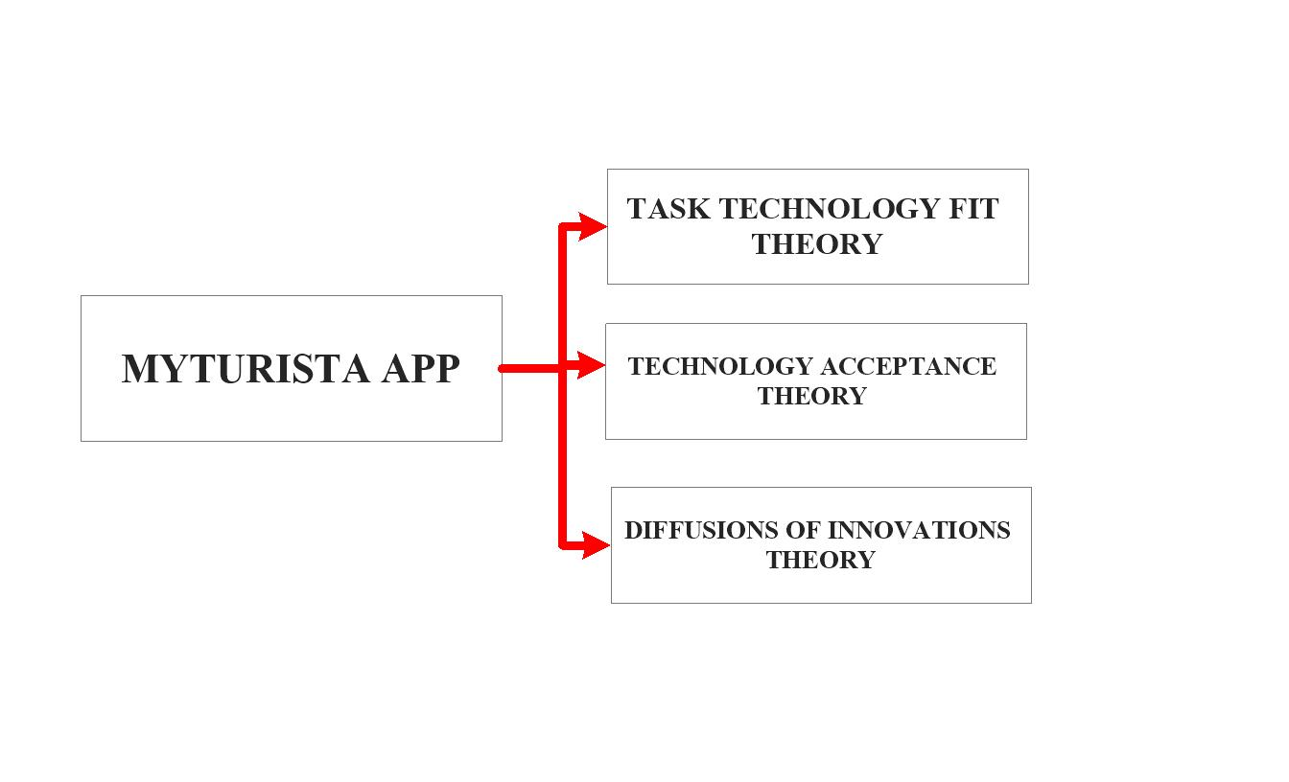

**Figure 1:** THEORETICAL FRAMEWORK DIAGRAM

# **CONCEPTUAL FRAMEWORK OF THE STUDY**

The researcher developed the conceptual framework of the study using the different theories or concepts used in the theoretical framework of the study. It is developed for a purpose to provide a clearer understanding and accurate design project plan and research design of the study. The proponent produced the conceptual framework of the study using the different theories of the theoretical framework with the support of concepts and models used in the conceptual framework. This is also developed for the purpose of providing a clearer understanding and accurate design project plan of the research study. This aims that the project system is to search and view different establishments in Metro Dumaguete with the use of Turista Mobile App. The System Development Life Cycle that researcher used is the Agile Model which are composed of planning, requirements analysis, designing phase, building and testing phase. The agile model is based on the adaptive software development method whereas traditional model development life cycle like waterfall is based on the predictive approach. According to (Szalvay, 2004), the Agile model is based on incremental of ideas and iterative development, in which the phases within the development life cycle revisited over and over again. Its iteratively improves the software by using the customer’s feedback or suggestions to converge on different solutions. Each builds are produced by iterations. Every iteration typically lasts about one to three weeks. In every iteration involves cross functional working team simultaneously on various areas like planning, requirements analysis, designing phase, coding phase, unit testing phase and acceptance phase.

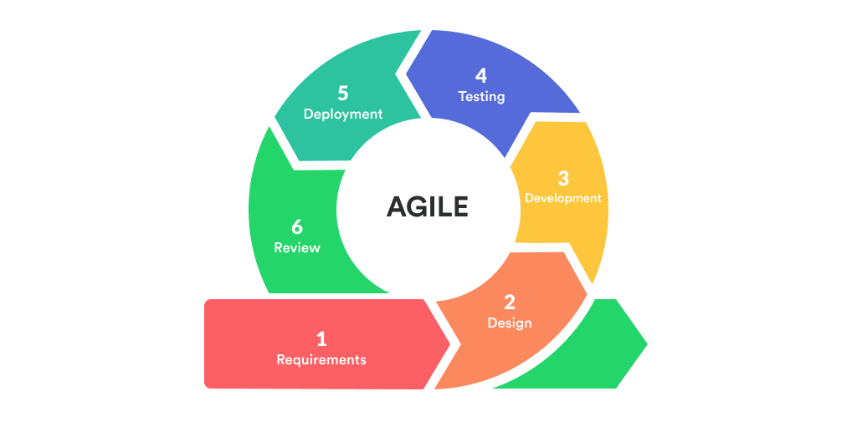

**Figure 2:** CONCEPTUAL FRAMEWORK DIAGRAM

# **REVIEW OF RELATED LITERATURE AND STUDIES**

This review of related literature and studies about different concepts, diagrams, studies from different authors, their own understanding and ideas used in this study. Generalizations or even conclusions that is related in the review. The review of related literature and studies supports on the study about mobile app development on tourism, android application on mobile phones and also it includes the Turista Mobile Application. Those that were also included as part of this chapter that will help and understand the relevance on mobile application on tourism both information and navigation.

Many people uses mobile technology as searching, playing games, texting, and viewing application on mobile phones. Under this review of related literature and studies section, it represents the different books, journals, research and other primary and secondary information that will pertain to the study.

According to Braehler, Stefan (Android Architecture, 2010), implies that smart phones and other mobile phones, more becoming more popular and easier in using different applications. Android is an operating system for low powered devices, which will run in a battery and full of hardware. Based on the study, it states in the statement that an android development for embedded systems like mobile phones. This literature about the component of the android development tells the different form that the android will do. This is to help us on how we would evolved and innovates technology.

According to (Muhammad and Usman, 2010), there is a mobile system called or named as “Minotaurus” which combines the technologies to achieve the development of mobile, multimedia and tourist information system. This system, consisting of portable laptop, having a large range of storage capacities, capabilities of wireless connection to a worldwide information network and provides users functionality to access the World Wide Web, shopping, banking, reservations and other transactions.

There are many definitions of tourism and some understandings on how tourism is being defined, according to (Gunn and Var, 2002). Tourism is the temporary movement of people to destination outside their place of work and residence, the activities that will undertake during their stay in different destinations to cater to their needs of tourists.

According to (Gunn, 2002), it states that further points out the causes of travel to a destination that are grounded in the destination’s resources, natural and cultural and the attractions that relates to them. Future tourism development is dependent on the location and the quality of the natural resources that will support outdoor recreation sought by those travel markets.

According to (Pawar, 2016), it states that the smart travel guide locates independent systems have been detected as an important part. This system takes advantages of a light-weight mash up technology that combine more than one data source to create value added services. Another, the android-based city guide system be realized that to create query information systems for hotels, scenery and other places.

According to (Baus, Kruget & Wahlster, 2002), the system can take into the account of accuracy of positional information in the technical resources available in the current situation. Most mobile navigation systems provide location and information sensitivity, in which it could access at any place at the given time. There are several means of transportation have combination in order to reach in safe and accurate destinations. The Turista Mobile App, in terms of accuracy, the information on a specific establishment is accurate in terms of address, contact number and other details.

According to (Liu, Moskowitz, Greenwood, Lieberman and Wood, 1999), it states that mobile navigation system wherein it implements as an embedded system for vehicle that is easy to use and does not detract attention of the driver.

The Tourism Information Navigation System provides tourism information and assists tourists with their travel needs. Also, you will find various tourism information and program information plotted on maps with icons which makes it simple and easier to understand.

According to the mobile travel guide application, it states that the mobile application, it is easy to think that an android as a high-end mobile phone. It is a software platform rather than an operating system or an operating system with potential to be utilized in a wider-range of devices.

According to (Hopken, Fuchs, Zanker & Beer, 2010), it states that are important roles in tourism and it gives access that is relevant to user’s information especially during travel. It gives more difficult by giving access to mobile applications with more ubiquitous environment, based on time management and effort for user’s acceptance in mobile applications. According to (Zarmpou, Drosopoulou & Vlachopoulou, 2013), focuses on mobile app on tourism regarding its specific dimensions on business models used in results to literature. Also, the importance of mobile technology to our society enhances more services and competitiveness. To ensure a good experience on mobile tourism in our day-to-day basis. Many tourists and even locals used navigation mobile application in searching and viewing information about establishments. It gives accurate information about a certain destination or even tourists spots.

According to (Kim, Chung & Ahn, 2017) it states that field of tourism is major essential element in making one’s travelled a more satisfying experience. Tourism information and navigation provides services with the use of mobile phones. There is a change in technology and innovation. According to (Cai, Richter & Mckenna, 2019), that information technology has played an important role in tourism industry and mostly travellers. Many technologies helps to reduce costs, enhanced operational efficiency and to improve services and the needs of users through experiences and satisfaction. There is a rapid development and implementation in information technology through tourism. According to (Jeong & Shin, 2019), it states that tourists uses mobile tourism technologies in different destinations for future use. In relation to tourism, it reduces emission and more sustainable usage of time and effort in searching and viewing the old traditional way. Technology has become essential to tourism industry in regards to locating different destinations in Metro Dumaguete.

According to (Ghaderi, Hatamifar & Ghahramani, 2019) it states that application of mobile phones provides local tourism experience in other places. It shows that the tourists’ satisfaction towards with mobile phones positively influences to participate in local and international tourism experiences. The widespread increase of the use of mobile phones has been transformed globally through tourists’ experiences on how to search and view destination easy, efficient and reliable.

According to (Brennan, Koo & Kyung, 2018) it states that focuses on tourist mobile app usage in smart tourism environment and also categorized through a taxonomy of mobile apps by framework and determines the factors in tourism trends by local and tourists visiting South Korea.

According to (Castaneda, Martinez Heredia & Rodriguez-Molina, 2019) it states that to ensure quality use of tourism mobile apps are as follows: the core attributes to deliver the best and cost-efficient, ease of use, and provides updates and accurate information to different destinations.

All factors are influenced to continue of using mobile applications that are designed for travel and leisure purposes. In using mobile app will usefully tool for locals and tourists to make an efficient, accurate, secured and hassle-free mobile application. It also provides an assessment for both consumers and stakeholders on how to adopt mobile tourism with the use of the Turista Mobile App. These mobile apps are to orient the needs of tourists’ satisfaction and intentions to visit different tourists’ spots and other destinations.

Mobile apps are integrated with different navigation-information sites to navigate, search and view destinations. Technological advances have more profound impacts the tourist’s mobility. Tourists and locals reviews are information sources for travellers to know about different destinations. The framework has been implemented to tourism mobile app that helps the locals and even tourists to search and view the best and new establishments, destinations in Metro Dumaguete and other places.

According to (Schmidt-Belz, Laamanen, Poslad & Zipf, 2003) it states that tourism considered potentially in using mobile technologies. The understanding on how tourist and locals organized activities and even problems faced in using mobile applications. It also describes how the tourists and locals collaborates the traditional way in searching, viewing and locating different locations, destinations and even new establishments.

# **RESEARCH METHODOLOGY**

This section presents the research methods, design, research environment, research instruments, research respondents, data gathering procedures and statistical treatment. Turista Mobile App will be focuses on the means of conducting the design and the scientific rationale for using designs and methods. It touches on a bit of theory but moreover on the practical application of the application of the design. The researcher will be used the questionnaire type of method.

Also, the researcher uses the Purposive Sampling and the Quantitative Research as to collect information, gather, assess and conducts questionnaire. Respondents are selected and conducted in terms of the number of locals and tourists per month and year. It focuses on one city and three municipalities: Dumaguete City, Municipality of Sibulan, Municipality of Bacong and the Municipality of Valencia. All the inquiries established and collected by researchers shall be answered thoroughly and honestly by the locals and tourists.

# **RESEARCH DESIGN**

The researcher uses purposive research sampling under quantitative approach. Purposive sample is where a researcher conducts and collects questionnaire based on the population of tourists and locals in Metro Dumaguete per month within a year. The researcher seeks to know from the respondents if the intended outcome of Turista Mobile App has been achieved and it needs further improvement. The survey conducted to know the population of foreign and Filipino nationalities per month within the year.

# **RESEARCH RESPONDENTS**

The selection of the respondents is assigned the total population sampling. With these sampling design, the researcher identifies and selects foreign and local people in Metro Dumaguete as part of the research. There is no specific age requirement.

# **RESEARCH ENVIRONMENT**

The locale of the study is in Metro Dumaguete composed of Dumaguete City, Municipality of Sibulan, Municipality of Bacong, and Municipality of Valencia. Dumaguete City has the total land area of 33.62km2. The total population of Dumaguete City is 134,103 as of 2020 Census. Dumaguete City is the 3rd income class component city and the capital city of Negros Oriental. Dumaguete City has 30 barangays. The total population of the Municipality of Sibulan is 64,343 as of 2020 Census. It is the 2nd class municipality in the province of Negros Oriental and has the total land area of 163.00 km2. Municipality of Sibulan has 15 barangays. The total population of the Municipality of Bacong is 41,207 as of 2020 Census. The total land area of this municipality is 40.30 km2. It is the 4th class municipality of Negros Oriental and also the coastal municipality. Municipality of Bacong has 22 barangays. The total population of the Municipality of Valencia is 38,733 as of 2020 Census. The total land area of this municipality is 147.49km2. It has 24 barangays. It is the 1st class municipality in the province of Negros Oriental.

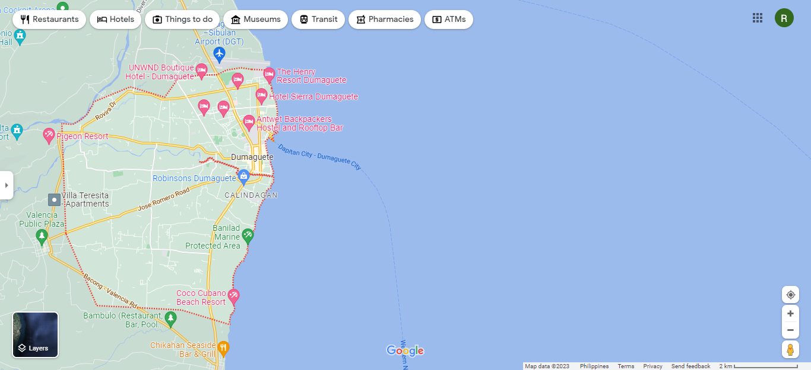

**Figure 3:** MAP OF DUMAGUETE CITY

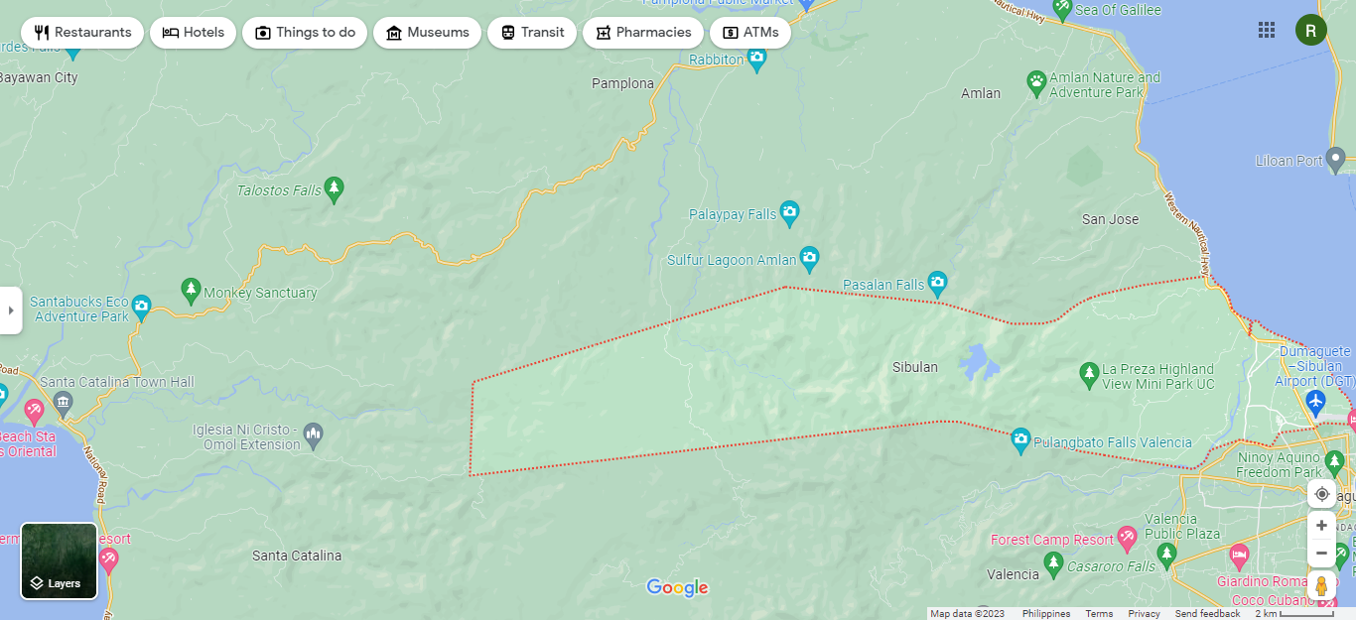

**Figure 4:** MAP OF MUNICIPALITY OF SIBULAN

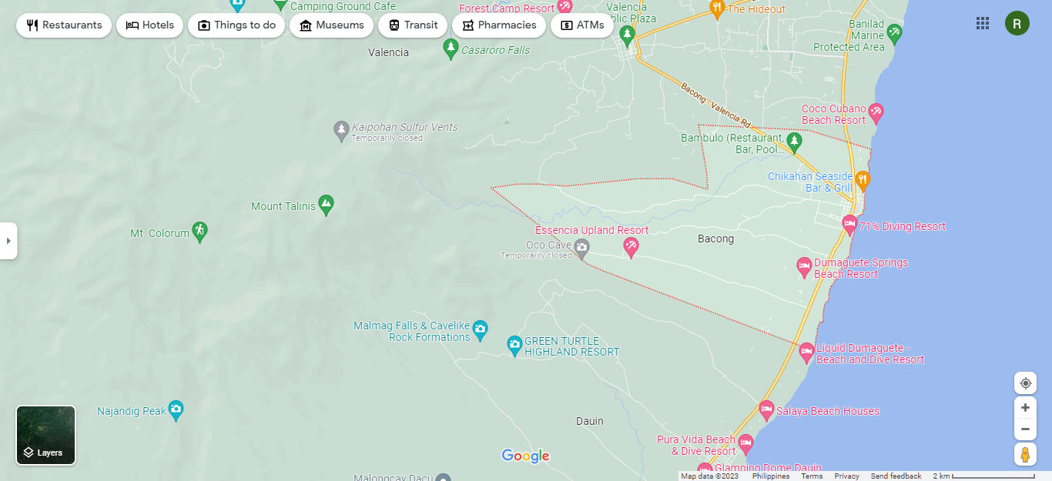

**Figure 5**: MAP OF MUNICIPALITY OF BACONG

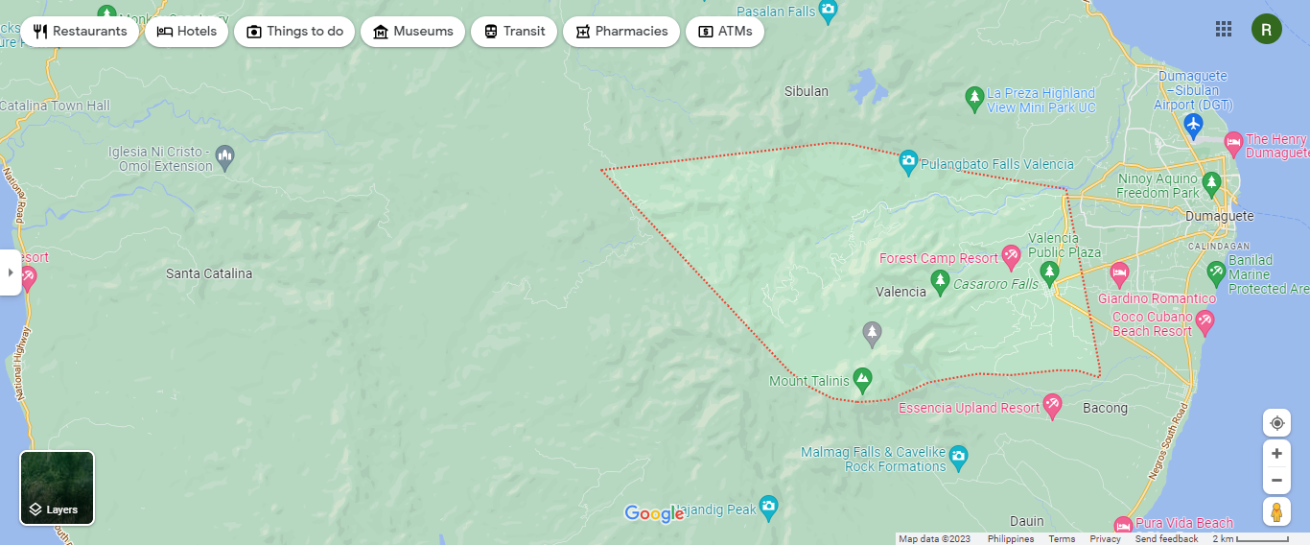

**Figure 6:** MAP OF MUNICIPALITY OF VALENCIA

TOURISM POPULATION

This study pertains the tourism of Metro Dumaguete consists of Dumaguete City, Municipality of Sibulan, Municipality of Bacong, and Municipality of Valencia as the primary source of the study. Having the partial number of tourists from 2018-2019 in Metro Dumaguete. The total population of tourists in 2018 is 673, 179. For 2019, the total population of tourists is 603, 077. These are the total population of tourists and locals in each municipality are as follows:

DUMAGUETE CITY

Total Population for both Foreign and Local Tourists in 2018: 656, 151

Total Population for both Foreign and Local Tourists in 2019: 798, 419

MUNICIPALITY OF SIBULAN

Total Population for both Foreign and Local Tourists in 2018: 1,300

Total Population for both Foreign and Local Tourists in 2019: 1,343

MUNICIPALITY OF BACONG

Total Population for both Foreign and Local Tourists in 2018: 1,423

Total Population for both Foreign and Local Tourists in 2019: 2,045

MUNICIPALITY OF VALENCIA

Total Population for both Foreign and Local Tourists in 2018: 14, 314

Total Population for both Foreign and Local Tourists in 2019: 12, 972

The total number of tourists in Metro Dumaguete (Dumaguete City, Municipality of Sibulan, Municipality of Bacong and Municipality of Valencia) is: 673, 188 in the year 2018. The total number of tourists in Metro Dumaguete (Dumaguete City, Municipality of Sibulan, Municipality of Bacong and Municipality of Valencia) is: 814, 779 in the year 2019.

It shows the number of tourists in Dumaguete City in the year 2018, the highest number of tourists is for the month of February. Foreign Nationality or even Filipino Nationality visits Metro Dumaguete (Dumaguete City, Municipality of Sibulan, Municipality of Bacong, and Municipality of Valencia) to go to different tourists’ spots or establishments.

**Figure 7:** TOTAL NUMBER OF TOURIST NATIONALITY IN DUMAGUETE CITY

**Figure 8:** TOTAL NUMBER OF TOURIST NATIONALITY IN MUNICIPALITY OF SIBULAN

**Figure 9:** TOTAL INFLUX OF TOURIST NATIONALITY IN MUNICIPALITY OF BACONG

**Figure 10:** TOTAL INFLUX OF TOURIST NATIONALITY IN MUNICIPALITY OF VALENCIA

The highest number of tourists per month, the month of January. The lowest influx of tourists per month is the months of February and March 2018.

**Figure 11:** TOTAL INFLUX OF DUMAGUETE CITY FOR 2019

It shows the number of tourists in the City of Dumaguete in the year 2019. The highest number of tourists in Dumaguete City per month is the month of November. The lowest number of tourists per month is July under the foreign nationality.

**Figure 12:** INFLUX FOR TOURIST NATIONALITY FOR MUNICIPALITY OF SIBULAN (2019)

It shows the number of tourists in the Municipality of Sibulan in the year 2019. The highest number of tourists per month, the month of February. The lowest number of tourists per month is the month of July in the year 2019.

**Figure 13:** TOTAL INFLUX OF TOURIST NATIONALITY IN MUNICIPALITY OF BACONG 2019

It shows the number of tourists in the Municipality of Bacong in the year 2019. The highest number of tourists per month is the month of May. The lowest number of tourists per month are the month of February and September in the year 2019. There is no foreign nationality visited in Metro Dumaguete.

**Figure 14:** TOTAL INFLUX FOR TOURIST NATIONALITY IN MUNICIPALITY OF VALENCIA 2019

It shows the number of tourists in the Municipality of Valencia in the year 2019. The highest number of tourists per month is the month of April 2019. The lowest number of tourists per month is the month of January 2019 for Filipino Nationality who visits the Municipality of Valencia. There is no Foreign Nationality visits in the Municipality of Valencia.

**Figure 15:** TOTAL NUMBER OF TOURIST NATIONALITY 2018-2019

It shows the total number of tourists in Metro Dumaguete in the year 2018-2019. The highest number of tourists within Metro Dumaguete is Dumaguete City. The lowest number of tourists within Metro Dumaguete are the Municipality of Sibulan, Municipality of Bacong and the Municipality of Valencia.

# **RESEARCH INSTRUMENTS**

In the research instrument, the researcher used the unstructured questionnaire wherein the type of questions in the questionnaire that calls a free response to the respondent’s own words in terms of questions. Since the data are collected specifically in quantitative research that helps in answering questions, the researcher must be carefully selected the number of respondents.

These items asks the following questions: existing tools used for tourists in guiding or locating tourists destinations and tourists spots in Metro Dumaguete, problems encountered in searching different destinations to tourists in Metro Dumaguete, designing and developing an effective Turista Mobile App for tourists in Metro Dumaguete, features or add-ons in Turista Mobile App in Metro Dumaguete and lastly the implementation on Turista Mobile App in Metro Dumaguete consists of city and municipality: Dumaguete City, Municipality of Sibulan, Municipality of Bacong and the Municipality of Valencia.

# **DATA-GATHERING PROCEDURES**

The researcher has allotted time and effort in creating and developing the questions in the questionnaire that is based in the statement of the problem so as to serve its respondents. The questionnaire was created using suitable questions that are being modified from related studies and individual questions that is formulated by the researcher. In the questionnaire, Unstructured Questionnaire was used to determine and selected the number of respondents or tourists in Metro Dumaguete.

The data gathered from this research instrument were computed for interpretation according to the influx of tourists within the year that answering the questionnaire honestly and accurately. Along with primary data, the researcher was also made use of the secondary resources like published articles and literatures to support the questionnaire results.

The method of purposive sampling was to use to develop the sample of the research under discussion. According to this method, the category of non-probability sampling techniques, samples are selected on the basis of their knowledge and expertise regarding his or her research.

# **STATISTICAL TREATMENT OF DATA**

The examination will consider the responses and reactions of the respondents especially the tourists which are the persons involved in this study with the use of the questionnaire. By its nature of being an observational kind of measurement, some statistical tools such as: mean, rate, percentage and sampling size.

To know whether there is a difference between of testing the app and the questions from the questionnaire. This research study will be using the Pearson Correlation Coefficient as the level of significance. Mean will be used as to sum up all the individual total population of tourists divided by the number per month category in the annual report.

**Statistical Analysis of the Data**

In the process, the data obtained through the questionnaire, the researcher will be utilized the following inferential statistics:

For problem 1, in which will determine the existing tools used in guiding or locating destinations and tourists’ spots.

For problem 2, in which will determine the problems encountered to tourists in locating or guiding destinations and tourists’ spots.

For problem 3 and problem 4, in which will be determine the output of the mobile app according to its features and its functionality.

For problem 5, in which will be determine the sample size, percentage, the level of significance according to the number of tourists per month and year.

**CHAPTER 2**

**PRESENTATION, ANALYSIS AND INTERPRETATION OF DATA**

# **INTRODUCTION**

This chapter presents the data gathered, the results of the statistical analysis and the interpretation of findings. These inputted tables of the following sequence of the specific statement of the problem of the effectiveness of the Turista Mobile App in Metro Dumaguete composed of the following city and municipality: Dumaguete City, Municipality of Sibulan, Municipality of Bacong and the Municipality of Valencia.

# **EXISTING TOOLS USED IN NAVIGATING DESTINATIONS**

These are the existing tools used in navigating or locating information to a specific location or even a destination within Metro Dumaguete or a certain municipality.

**Figure 16:** TOOLS USED FOR NAVIGATING DESTINATIONS IN METRO DUMAGUETE

|  |  |
| --- | --- |
| EXISTING TOOLS USED IN NAVIGATION | TOTAL TALLY |
| DUMAGUETE WEBSITE | 0 |
| PROVINCIAL TOURISM WEBSITE | 16 |
| GOOGLE MAPS | 103 |
| WAZE GPS, MAPS AND TRAFFIC | 12 |
| TOURIST GUIDEPOST SIGNS | 58 |
| MAP MANUALS | 64 |
| GPS FOR CARS | 0 |
| HERE WE GO MAPS | 0 |
| SYGIC: GPS NAVIGATION AND OFFLINE MAPS | 0 |
| CITYMAPPER | 0 |
| DRIVE MODE | 0 |
| GPS ESSENTIALS APP | 58 |
| POLARIS NAVIGATION GPS | 0 |
| GOOGLE EARTH | 25 |
| GPS NAVIGATION AND TRACKER | 15 |
| MAP FACTOR | 0 |
| MAVERICK: GPS NAVIGATION | 0 |
| OFFLINE MAPS AND NAVIGATION | 70 |
| MOOVIT | 0 |

**Table 1:** TOOLS USED IN NAVIGATING DESTINATIONS IN METRO DUMAGUETE

It both shows that the tools used for navigating destinations in Metro Dumaguete respondents has the highest number of tallies: 103 percent which is Google Maps and the least number of tallies that the respondents answered are both 2 percent: Provincial Tourism Website and Waze GPS, Maps and Traffic. These are the existing tools used in navigating destinations in Metro Dumaguete (Dumaguete City, Municipality of Sibulan, Municipality of Bacong, and Municipality of Valencia).

# **PROBLEMS ENCOUNTERED BY TOURISTS IN LOCATING DESTINATIONS**

These are the following problems that the tourists or even locals encountered in assisting, locating or navigating in different destinations in Metro Dumaguete and other municipalities like Municipality of Sibulan, Municipality of Bacong and Municipality of Valencia.

**Figure 17:** PROBLEMS ENCOUNTERED TOURISTS WITH THE CURRENT NAVIGATION TOOLS USED

|  |  |
| --- | --- |
| PROBLEMS ENCOUNTERED TO TOURIST IN NAVIGATING DESTINATIONS | TOTAL TALLY |
| LANGUAGE BARRIER | 107 |
| RELIABILITY | 32 |
| DISPLAYING INCORRECT LOCATION | 20 |
| INCORRECT ROAD NAMES | 8 |
| MISSING ROADS | 14 |
| WRONG ADDRESS OR MARKER LOCATIONS | 2 |
| TRAFFIC JAMS | 0 |
| UNMARKED ROADS | 1 |
| VISIBILITY | 1 |
| GPS DEVICE IS NOT VERY ACCURATE IN GIVING LOCATION | 11 |
| GPS MOVEMENT | 9 |
| HUMAN INTERVENTION | 58 |
| POOR MOBILE NETWORK COVERAGE | 58 |
| NO POWER | 44 |
| ROUTE NOT FOUND | 38 |
| ALTERNATIVE ROUTE FEATURES IS LOCKED IN THE FREE VERSION, YOU’LL HAVE TO PAY FOR IT TO UNLOCK | 0 |
| NO OFFLINE RE-ROUTING | 2 |
| NO LANE GUIDANCE | 3 |
| SLOW RENDERING | 3 |
| POOR NAVIGATION INTERFACE | 44 |

**Table 2:** PROBLEMS ENCOUNTERED TOURISTS WITH CURRENT TOOLS USED

It represents the problems encountered to tourists in assisting, locating, or even navigating places or destinations in Metro Dumaguete (Dumaguete City, Municipality of Sibulan, Municipality of Bacong and the Municipality of Valencia). According to the total tally wherein the highest number of respondents answered in the questionnaire: Language Barrier- 107 percent. Communication becomes difficult in other situations where people don’t understand each other’s languages. The least number of tallies in question number 2 are: Unmarked Roads and Visibility are both 2 percent as the total tally.

# **THE EFFECTIVENESS OF TURISTA MOBILE APP IN METRO DUMAGUETE**

The effectiveness of a mobile navigation tourism app for either tourist or even locals is to assists in accessing the tourism app. These are the non-functionality requirements that will help the tourists or locals of using the mobile application.

**Figure 18:** EFFECTIVENESS OF TURISTA APP IN METRO DUMAGUETE

|  |  |
| --- | --- |
| NON-FUNCTIONALITY REQUIREMENTS | TOTAL TALLY |
| EASY TO USE | 100 |
| ACCURACY | 19 |
| ACCESSIBILITY | 52 |
| PORTABILITY | 48 |
| CLARITY OF INFORMATION | 36 |
| MAINTAINABILITY | 41 |
| RELIABILITY | 38 |
| EFFECTIVENESS | 44 |
| COMPATIBILITY | 22 |
| INSTALLABILITY | 34 |

**Table 3:** TOTAL INFLUX FOR EFFECTIVENESS OF TURISTA APP

It represents the total tally of the non-functionality requirements for using the turista mobile app. Out of the 97 responded, the highest total tally of answered questions is the Easy to Use (100%). The least total tally of the effectiveness or non-functionality requirements used in Turista Mobile App is Accuracy (19%). The user (locals or even tourists) makes sure that the app must a user-friendly type of application, easy to use app but not too complicated. It must be clear in terms of information, destinations, places and navigation.

# **FEATURES OF A MOBILE NAVIGATION TOURISM APP IN METRO DUMAGUETE**

These are the features of Turista Mobile App: Info Board which includes the History, Fun Facts and the Tourism Information Portal (Hotels, Restaurants, Beach Resorts, Tourists Spots and other legend category), Gallery (Photos and Videos) and Turista Information Portal.

**Figure 19:** FEATURES OF TURISTA APP

|  |  |
| --- | --- |
|  | TOTAL TALLY |
| INFORMATION BOARD | 44 |
| LISTS OF ESTABLISHMENTS | 51 |
| HISTORY | 59 |
| FUN FACTS | 62 |
| INFORMATION ABOUT ESTABLISHMENTS | 41 |
| NAVIGATION MAPS | 79 |
| TOURISM MAPS | 47 |

**Table 4:** FEATURES OF TURISTA APP

It shows that the highest total tally is Navigation Maps with 79 percent out of 97 responded questionnaires. The least total tally is information about a certain establishment with 41 percent out of 97 responded questionnaires. The navigation maps must be accurate in terms of the directions, information, road tracking and new names of an establishment.

# **TOURISTS INFLUX BY GENDER**

The tourists influx by gender are composed of year, gender (male, female and others), and the total influx by gender. It shows the total number of tourist’s influx according to their gender. Assumes that if the registered tourist or local is male, female or others, the results will be counted and determined in the database.

**Figure 20:** TOTAL INFLUX BY GENDER

# **TOURIST INFLUX BY NATIONALITY**

The influx for tourist by their nationality composed of locals (Filipino nationality) and tourists (Foreign nationality), month and the specific year, the total influx for both tourists category. The total computation that results to the number of tourist category per month within a year.

For Filipino Nationality computation:

$$n=the sum of the total number of filipino nationality per month$$

For Foreign nationality computation:

$$n=the sum of the total number of foreign nationality per month$$

For Example: Total Influx of Tourist Nationality per month

Total Number of Tourist Nationality:

$$n=the sum of total influx of local nationality and foreign nationality$$

# **INFLUX OF TOURISTS BY PLACE OF ORIGIN**

The total influx for tourists according to the place of origin with their place category. The computation of influx for tourist

by place of origin:

$$n= the sum of the total population of tourist by place category per month$$

For the total number of tourists’ by place of origin:

$$n=the sum of the subtotal influx per place category$$

**CHAPTER 3**

**TECHNICAL ASPECTS OF TOURISM MOBILE APP IN METRO DUMAGUETE**

# **INTRODUCTION**

In this chapter, it includes the main purpose of the android app and how it works, the android development and its implementation, the peripheral model of the android app development, the diagrams used includes the following that will be fitted in this study: the entity relationship diagram, the activity diagram, the use case diagram and the database. There will be a software deployment and testing of the android app that will be part of the study.

# **PURPOSE AND DESCRIPTION**

The purpose of the study is to understand and know the old and new history and facts of each place and destinations. “TURISTA” is the acronym, meaning:

T: to know the meaning of the old and new history of Metro Dumaguete that is composed of one city and three municipalities, these are: Dumaguete City, the Municipality of Sibulan, the Municipality of Bacong and the Municipality of Valencia in this generation.

U: to understand the true meaning of each place and destinations and how it is being used in the new generation.

R: it must be accurate and true in terms of locating or searching different establishments and tourist spots in Metro Dumaguete.

I: to innovate new ideas and innovations in terms of developing the android application in tourism for Metro Dumaguete.

S: to study the history, fun facts and barangay of each city or municipality.

T: to transform old to new technology that will locate or search destinations or tourists’ spots.

A: to have an accurate information based on fun facts, history, navigation maps and tourism maps.

# **ANDROID DEVELOPMENT SPECIFICATION**

Here are the android specifications are as follows:

|  |  |
| --- | --- |
| **ANDROID SPECIFICATION** | |
| Category | Any android phone/tablet |
| Operating System | Android 10.1 compatibility |
| Resolution | 1440 x 2560 pixels, 6.22 inches |
| Processor | MediaTek Helio P22 |
| Storage | 32GB |
| RAM | 2GB |
| Battery capacity | 4030mah |
| Dimensions | 155.11 x 75.09 x 8.28 |

# **ANDROID PRODUCTIVITY PERSPECTIVE AND ITS GENERAL FEATURES**

TURISTA: A MOBILE TOURISM APP helps the users to view, search or even add destinations or establishments and many more. However, these are just basic the use of a navigation app or tourism app. This are the different add-ons that will entertain and delivered more services to the locals or tourists.

**FOR ADMIN USERS ONLY:**

1. LIST OF TOURISTS REGISTERED: These are the list of tourist and locals registered in the database.
2. LIST OF TOURIST INFLUX: It has 2 types of tourist influx: by gender and by place of origin. (B.1) BY Gender: The total number of male and female according to year and months from January to December. (B.2) BY Place of Origin: The total number of category, the category composed of ASIA-ASEAN, EAST ASIA, SOUTH ASIA, MIDDLE EAST, AMERICA-NORTH AMERICA, SOUTH AMERICA, EUROPE-WESTERN EUROPE, NORTHERN EUROPE, SOUTHERN EUROPE, EASTERN EUROPE, AUSTRALASIA/PACIFIC, AFRICA with their respective place of origin.
3. LIST OF TOURIST NATIONALITY: There are 2 categories of nationality, Filipino or local nationality and foreign or tourist nationality. The total number of local and foreign nationality with their specific/respective year and month from January to December.
4. LIST OF LEGEND AND ESTABLISHMENTS: Legends are the list of major categories like Hotels, Restaurants, Beach Resorts, Hospitals, Church, Tourist Spots, Banks, Ports, and other major categories of legends. List of Establishment are list of information details like name of establishment, address, contact details, URL link, photo and a photo of an accurate navigation map.

**FOR TURISTA AND LOCALS ONLY:**

1. HISTORY PORTAL: It is composed of the 4 places in Metro Dumaguete with their respective history and barangay. It consists of: Dumaguete City, Municipality of Sibulan, Municipality of Bacong and the Municipality of Valencia.
2. FACTS PORTAL: It is composed of the facts about food, place, persona, art and culture and many more.
3. GALLERY PORTAL: It is composed of random photos and videos about Metro Dumaguete.
4. TURISTA INFORMATION PORTAL: It is an information portal wherein the tourist and local by searching and viewing an establishment. It will gives an accurate information about the name, address, contact details, the URL link, and the navigation map photo.

# **HARDWARE AND SOFTWARE REQUIREMENTS**

Here are the hardware and software requirements:

|  |  |
| --- | --- |
| **HARDWARE REQUIREMENTS** | |
| PROCESSOR | Octa-core Qualcomm Snapdragon 439 |
| PROCESSOR MAKE | Mediatek Helio P22 (MT6762R) |
| INTERNAL STORAGE | 32GB |
| EXPANDABLE STORAGE | YES |
| EXPANDABLE STORAGE TYPE | MICRO SD |
| EXPANDABLE STORAGE TYPE UP TO (GB) | 256 |

|  |  |
| --- | --- |
| **SOFTWARE REQUIREMENTS** | |
| OPERATING STSTEM | Android 10.1 compatibility |
| SKIN | Funtouch OS 4.5 |

# **TURISTA MODELS AND DIAGRAMS**

# FLOWCHART (TURISTA USER)

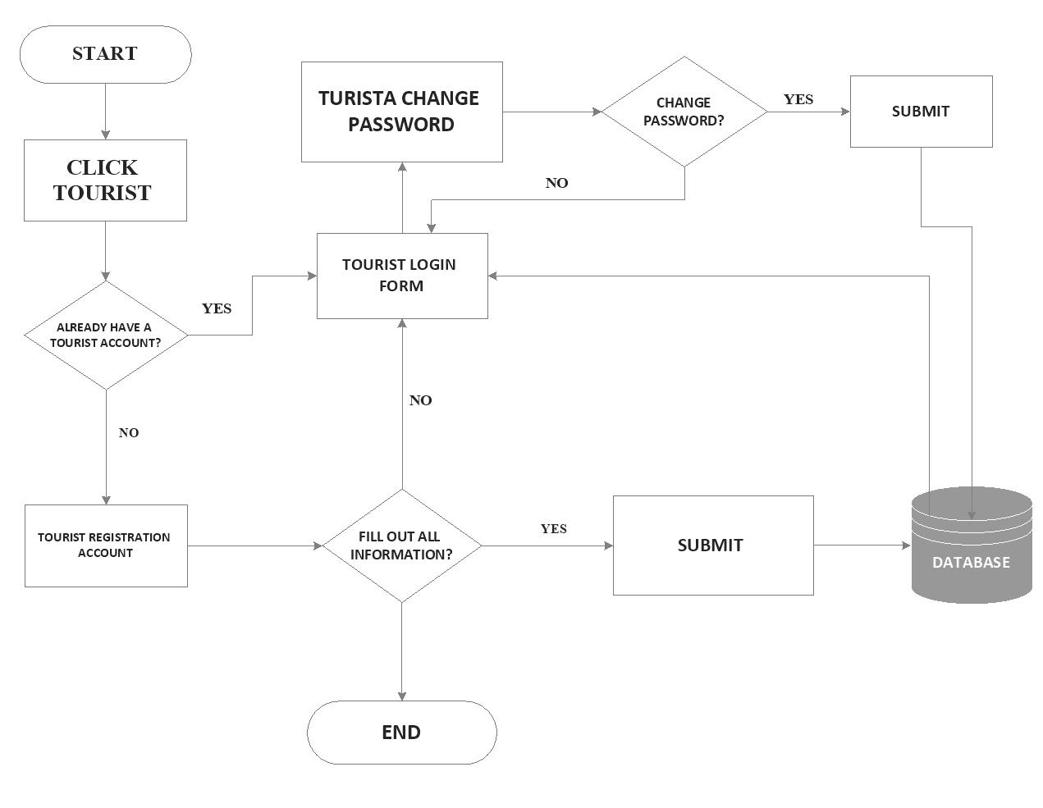

**Figure 21:** FLOWCHART FOR USER REGISTRATION

It is a graphical representation of a flowchart Turista Mobile App wherein the new user can register the turista registration form before login and it will goes to the database.

# ADMIN USER FLOWCHART

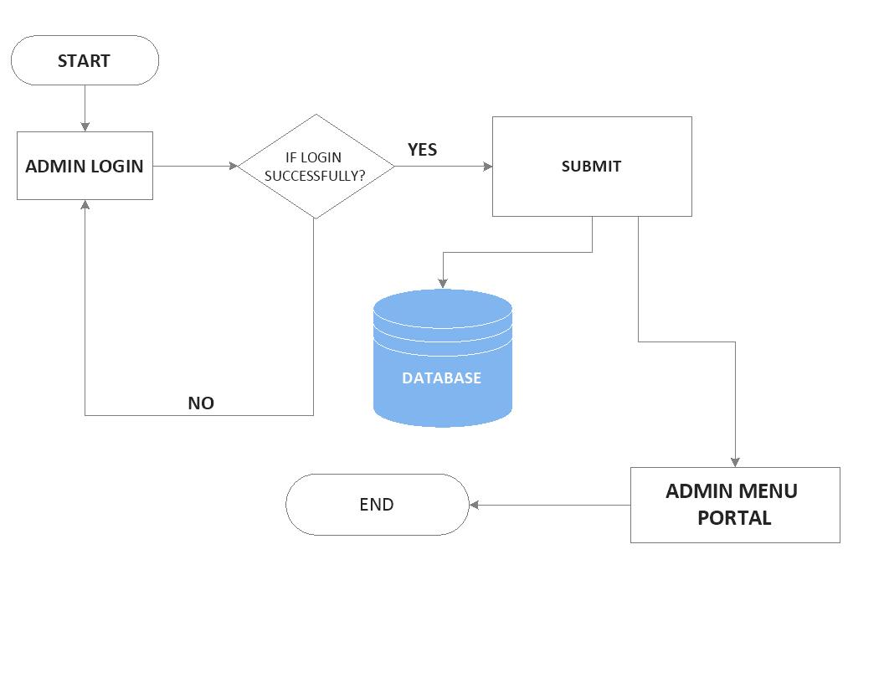

**Figure 22:** ADMIN USER FLOWCHART

It is the diagram representation of the admin user flowchart wherein the admin user will login his/her username and password that will submit to the database. If the username and password are inputted successfully, it will passed through the Admin Menu Portal.

# C:\Users\jesse\OneDrive\Desktop\ERD PAGE Q (5).jpgENTITY RELATIONSHIP DIAGRAM

**Figure 23:** ENTITY RELATIONSHIP DIAGRAM

Legends: Many-to-many C:\Users\jesse\OneDrive\Desktop\New folder\FINAL DOC\Many to Many.jpg One-to-many C:\Users\jesse\OneDrive\Desktop\New folder\FINAL DOC\One to many.jpg

It has 2 main entities: admin user and turista user, the admin user will login the username and password and it will submit to the database. The admin user can view the list of tourist registered, list of tourist’s influx by gender, place of origin and its nationality. The admin user can add, delete, search and view, update an information about establishment and places in the list of legends and establishments. The tourist user can view one or more establishments in the list per legend category. The admin user can view one or more list of tourists registered. The admin user can view and prints one or more information about list of tourists’ influx by gender, place of origin and nationality.

# DATA FLOW DIAGRAM

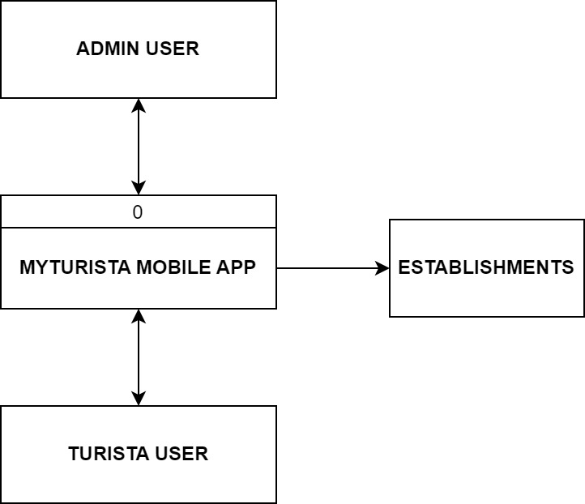

**Figure 24:** DATA FLOW DIAGRAM

This diagram shows the data flow on Turista Mobile App. It has two entities: the admin user and the turista/tourist user. A Data Flow Diagram for Turista Mobile App is used for Tourism Mobile Application, it is a data flow which represents the major process of view and search different establishments and view different portals like history, facts and gallery in Turista Mobile App.

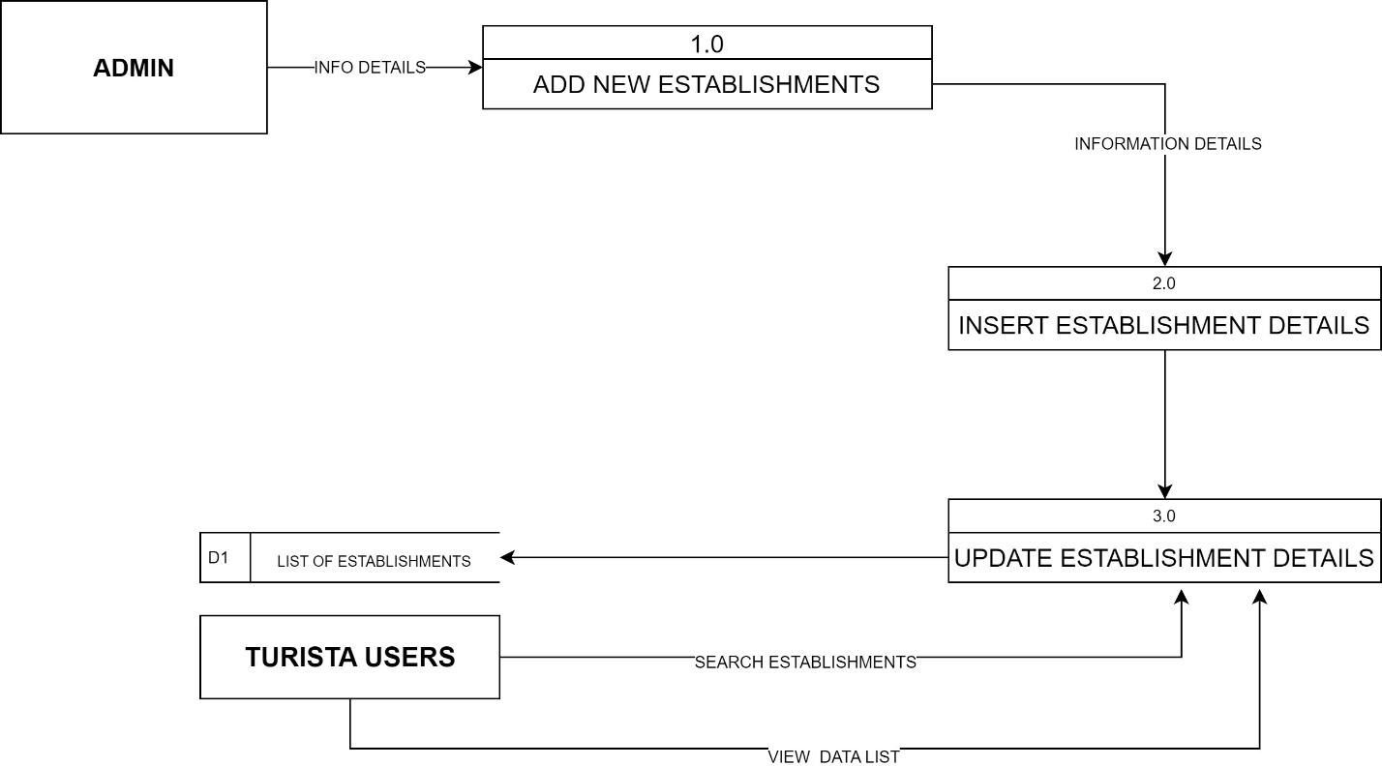

**Figure 25:** LEVEL 1 CONTEXT FLOW DIAGRAM

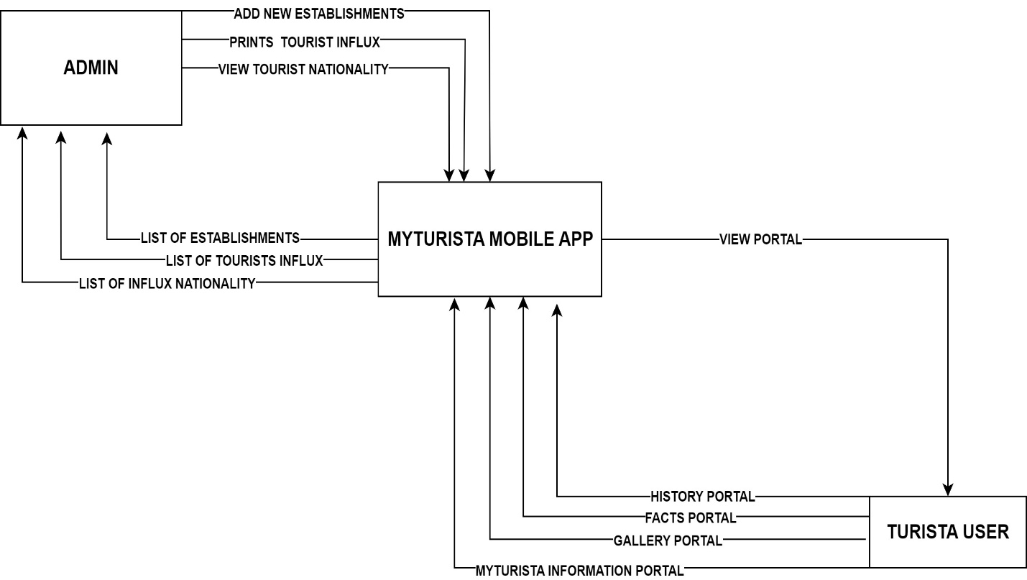

**Figure 26:** CONTEXT FLOW DIAGRAM

# USE CASE SCENARIO AND USE CASE DIAGRAM



**Figure 27:** USE CASE DIAGRAM

**MAIN SUCCESS SCENARIO**

|  |  |  |
| --- | --- | --- |
| STEP | ACTOR | ACTOR DESCRIPTION |
| 1 | LOCAL/TOURIST | The main menu pops-up. The following fields are available:  Main Menu  History w/ list of barangay  Fun Facts  Photos  Videos  Tourism Information Portal  History Menu  History of Dumaguete City  History of Municipality of Sibulan  History of Municipality of Bacong  History of Municipality of Valencia  Tourism Information Portal  Restaurants  Beach Resorts  Hotels  Tourist Spots and many more category legends  The main menu includes downloading option |
| 2 | USER/IT | IT/USER can update the system app, navigation map and all the information of the Turista App. |
| 3 | TOURIST/LOCAL | Tourist/Local can search the location/establishments. |
| 4 | USER/IT | Update/Add new establishments/location. |

**Table 5:** MAIN SUCCESS SCENARIO

# ACTIVITY DIAGRAM

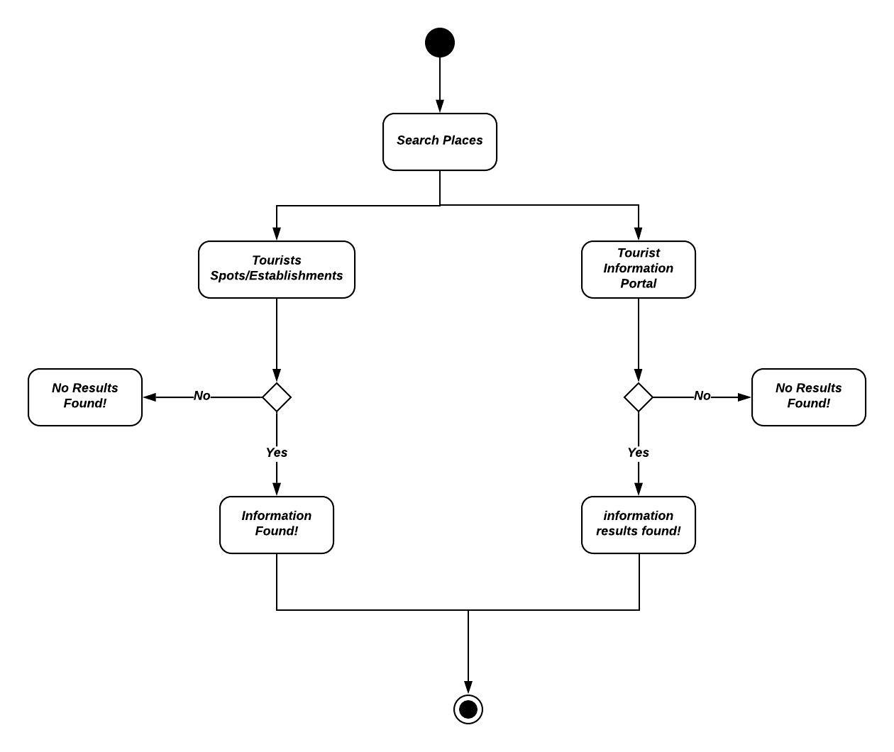

**Figure 28:** ACTIVITY DIAGRAM

# **TURISTA APP NON-FUNCTIONALITY REQUIREMENTS**

In the non-functional requirements, the mobile app has four testing processes are

as follows: functional testing, performance testing, usability testing and lastly the

Compatibility testing.

1. **Functional Testing**: the functional testing of mobile normally consists in the

areas of testing user interactions as well as testing the Turista mobile app. The

various factors which are relevant in functional testing are:

1. Type of application is based upon the business functionality usages.
2. Target audience type (locals and tourists)
3. Distribution channel which is used to spread the application.
4. **Performance Testing**: this type of testing’s fundamental objective is to ensure

that the application performs acceptably under certain performance

requirements such as access by a huge number of users or the removal of a

key infrastructure part like a database server.

The general test scenarios for performance testing in a mobile app are:

* 1. To determine whether the application performs as per requirement under different load conditions.
  2. To determine whether the current network coverage is able to support the application at peak, average and minimum user levels.
  3. To validate the network performance while moving around with the device.
  4. To validate the application longevity whenever the user load is rigorous.
  5. To validate that the battery consumption, memory leaks, resources like GPS, camera performance is well within required guidelines.

1. **Usability Testing:** the usability testing process of the mobile application is

performed to have a quick and easy step application with less functionality than

a slow and difficult application with many features. The main objective is to

ensure that we end up having an easy-to-use, intuitive and similar to industry

accepted interfaces which are widely used.

1. To ensure that the buttons should have the required size and be suitable to big fingers.
2. To ensure that the buttons are placed in the same section of the screen to avoid confusion to the end users.
3. To ensure that the icons are natural and consistent with the application.
4. To ensure that the buttons which have the same function should also have the same color.
5. To ensure that the validation for the tapping zoom-in and zoom-out facilities should be enabled.
6. To ensure that the application provides a method for going back or undoing an action, on touching the wrong item, within an acceptable duration.
7. To ensure that the contextual menus are not overloaded because it has to be used quickly.
8. To ensure that the text is kept simple and clear to be visible to the users.
9. To ensure that the short sentences and paragraphs are readable to the end users.
10. To ensure that the font size is big enough to be readable and not too big or too small.
11. To validate the application prompts the user whenever the user starts downloading a large amount of data which may be not conducive for the application performance.
12. To validate that the closing of the app is performed from different states and verify if it re-opens in the same state.
13. To ensure that the end users are provided with a user manual which helps the end user to understand and operate the application who may be not familiar with the application’s proceedings.
14. **Compatibility Testing:** compatibility testing on android mobile phones are

performed to ensure that since mobile devices have different size, resolution,

screen, versions and hardware so the application should be tested across all

the devices to ensure that the application works as desired:

To validate that the user interface of the application is as per the screen size of the device, no text/ control is partially invisible or inaccessible. To ensure that the text is readable for all users for the application.

**CHAPTER FOUR**

**SUMMARY OF FINDINGS, CONCLUSION AND RECOMMENDATIONS**

# **INTRODUCTION**

This chapter presents the brief re-statement of the problem, the summary of findings, conclusions and recommendations.

# **BRIEF RE-STATEMENT OF THE PROBLEM**

The previous chapters emphasize the problems encountered and existing tools used in searching and viewing to locals and tourists in Metro Dumaguete. People travel for a variety of reasons: to escape, explore, understand and participate. But at the core of the experience lies the destination – the place that hands something to traveler to keep forever and share with others. Destination, information and its point of interest is far less in some places like Metro Dumaguete. It needs a tool or kind of app to assist the tourist and locals in a very convenient way to explore the beauty of our city. This study seeks to develop a Turista Mobile App in Metro Dumaguete.

Specifically, it seeks to answer the following questions:

1. What are the existing navigation tools used by the Dumaguete City locals and tourists in locating point of interest?
2. What are the problems encountered by the locals and tourists with the current navigation tools in locating points of interest within Dumaguete City?
3. How to design and develop an Effective Turista Mobile App in Metro Dumaguete?
4. What are the features of an Effective Turista Mobile App in Metro Dumaguete?
5. How to implement the Turista Mobile App in Metro Dumaguete?

# **SUMMARY OF FINDINGS**

There are many findings used and assessed by its specific respondents. But not all the findings are effective for using the trial app of Turista Mobile App. Sometimes it only depends on the number of tourists per month in a year according to gender, place of origin and its nationality.

# **RECOMMENDATIONS**

From the findings and conclusions, these are the following recommendations:

1. Since the research indicates the number of respondents rely on the foreign tourists to what is important is to locate or even navigate maps accurately and maintainability in terms of information like address and business hours.
2. The current study shows that the gathering of data is enough to support that there is an effectiveness in using the Turista mobile app to locals or even foreign tourists.
3. A more investigation is also recommended to determine the accuracy of information or data in searching or locating maps.

# **CONCLUSIONS**

Based on the summary of findings, the following conclusions are as follows:

1. This research study is all about the Mobile Turista App for local and tourists in Metro Dumaguete in consists of one city and 3 municipalities that is 7 kilometers away in Dumaguete City, the Municipality of Sibulan, the Municipality of Bacong and the Municipality of Valencia.
2. Based on the findings under the statement of the problem and the interpretation of data, these are the results in collecting the data are as follows: the respondents have different results in terms of number of tourists per month both locals and foreign tourists. Among the foreign tourists, the highest number of tourists per month. These are existing tools used in map navigation for tourists, problems encountered by local or even foreign tourists, the designing and developing the mobile turista app in Metro Dumaguete, features used in the app and the effectiveness of turista mobile application.

# **REFERENCES**

Baus, J., Kruger, A., & Wahlster, W. (2002). A resource - adaptive mobile navigation system. *Proceedings of the 7th International Conference on Intelligent Users Interfaces*, (pp. 15-22). doi:https://doi.org/10.1145/502716.502716.502723

Braehler, Stefan (2010). Analysis of the android architecture. (Page 52). doi: <https://os.itec.kit.edu>

Brennan, B. S., Koo, C., & Kyung, M. (2018). Smart tourism: A study of mobile application use by tourists visiting South Korea. *Asia-Pacific Journal of Multimedia Services Convergent with Arts, Humanities and Sociology, 8*(10), 1-9.

Cai, W., Richter, S., & Mckenna, B. (2019). Progress on technology use in tourism. *Journal of Hospitality and Tourism Technology, 10*(4), 651-672. doi:https://doi.org/10.1108/JHTT-07-2018-0068

Castaneda, J.-A., Martinez-Heredia, M., & Rodriguez-Molina, M.-A. (2019). Explaining tourist behavioural loyalty toward mobile apps. *Journal of Hospitality and Tourism Technology, 10*(3), 415-430. doi:https://doi.org/10.1108/JHTT-08-2017-0057

Ghaderi, Z., Hatamifar, P., & Ghahramani, L. (2019). *How smartphones enhance local tourism experiences?* doi:https://doi.org/10.1080/10941665.2019.1630456

Gunn, C.A. and Var, T. (2002). Tourism planning: basics concepts cases. (pp. 287-288) doi: 10.1016/S0261-5177(03)00088-8

Hopken, W., Fuchs, M., Zanker, M., & Beer, T. (2010). *Context-based adaptation of mobile applications in tourism* (Vol. 12). Cognizant Communication Corporation.

Jeong, M., & Shin, H. (2019). *Tourists' experiences with smart tourism technology at smart destinations and their behaviour intentions.* doi:https://doi.org/10.1177/0047287519883034

Kim, J. Y., Chung, N., & Ahn, K. (2017). *The impact of mobile tour information services on destination travel intention.* doi:https://doi.org/10.1177/0266666917730437

Liu, T.-K., Moskowitz, P. A., Greenwood, M. G., Lieberman, L. I., & Wood, D. A. (1999). *Systematized for personalized mobile navigation information.*

Muhammad and Usman (2015). Supporting effort estimation in agile software development. doi: <https://www.diva-portal.org/>

Schmidt-Belz, B., Laamanen, H., Poslad, S., & Zipf, A. (2003). *Location-based mobile tourist services: first user experiences.* Enter 2003: 10th International Conference on Information Technology in Travel and Tourism.

Zarmpou , T., Drosopoulou, C., & Vlachopoulou, M. (2013). Mapping the tourism mobile applications: what, how, where. *Proceedings of the 6th Balkan Conference in Informatics*, (pp. 206-212). doi:https://doi.org/10.11451/2490257.2490295

# **APPENDICES**

**APPENDIX A**

**LETTER OF REQUEST**

February 27, 2020

**MYLA MAE BROMO-ABELLANA**

Senior Tourism Operations Officer

Negros Oriental Tourism Unit

Sidlakang Negros Village

Dear Ma’am Abellana,

Greetings!

I am RALPH JESSE ANTO, student of the Graduate School of Negros Oriental State University, taking up Masters of Science in Information Technology (MSIT). Currently, I am conducting a thesis entitled: “TURISTA MOBILE APP”.

The said study will benefit the tourists and locals who will visit the city and the province, locating important point of interest and other useful features.

To validate and to provide accurate basis of information for the development of the Turista App, May I humbly ask, if possible, the tourists influx data who visited the following city and municipality.

* Dumaguete City
* Municipality of Sibulan
* Municipality of Bacong
* Municipality of Valencia

I am hoping for your kind approval to this request.

Thank you very much.

Respectfully, Noted by:

**RALPH JESSE ANTO ROCHE L. CABANLIT**

MSIT STUDENT ADVISER

NORSU

**APPENDIX B**

**QUESTIONNAIRE**

Dear Respondents:

The questionnaire is designed to collect data, entitled: “**TURISTA MOBILE APP**”. Kindly fill out as honestly and accurate as possible. The data will be provided and treated with an utmost confidentiality. Thank you for your anticipated cooperation.

Instructions: Please put a checkmark (✅) complete the following questions in the questionnaire as accurately and honestly as possible.

1. Tools used for searching and viewing different destinations in Metro Dumaguete.

________________ Dumaguete Website

________________ Provincial Tourism Website

________________ Google Maps

________________ Waze GPS, Maps and Traffic

________________ Tourist Guidepost Signs

________________ Map Manuals

________________ GPS for Cars

________________ Here We Go Maps

________________ Sygic: GPS Navigation and Offline Maps

________________ CityMapper

________________ DriveMode

________________ GPS Essentials App

________________ Polaris Navigation GPS

________________ Google Earth

_________________ GPS Navigation and Tracker

_________________ Map Factor

_________________ Maverick: GPS Navigation

_________________ Offline Maps and Navigation

_________________ Moovit

Others please specify: ______________________________

1. Problems encountered by the tourists with the current navigation tool in locating point of interests in Metro Dumaguete.

___________ Language Barrier

___________ Reliability

___________ Displaying Incorrect Location

___________ Incorrect Road Names

___________ Missing Roads

___________ Wrong Addresses or Marker Locations

___________ Traffic Jams

___________ Unmarked Roads

___________ Visibility

___________ GPS device is not very accurate in giving locations

___________ GPS Movement

___________ Human Intervention

___________ Poor Mobile Network Coverage

___________ No Power

___________ Route Not Found

___________ Alternate routes feature are locked in free version

___________ No offline re-routing

___________ No Lane Guidance

___________ Slow Rendering

Others: please specify: _____________________________________

1. How effective is the Turista Mobile App as perceived by tourists and IT experts?

_________ Accuracy

_________ Accessibility

_________ Portability

_________ Clarity of Information

_________ Ease of Use

_________ Security

_________ Reliability

_________ Maintainability

_________Compatibility

1. Features added of an effective Turista Mobile App for Metro Dumaguete tourists and locals for future use.

_________ Information Board Portal (weather, news and many more).

_________ Quiz Portal

_________ Announcement Portal

_________ Calendar of Activities

Others please specify: ______________________________________________________

**APPENDIX C**

**TURISTA MOBILE APP EVALUATION CRITERIA ASSESSMENT**

The assessment evaluation criteria are grouped as follows:

1. **USABILITY**
2. Understandability
3. Documentation
4. Buildability
5. Installability
6. Learnability
7. **SUSTAINABILITY AND MAINTAINABILITY**
8. Copyright
9. Community
10. Accessibility
11. Testability
12. Portability
13. Supportability
14. Evolvability

|  |  |  |
| --- | --- | --- |
| **Criterion** | **Sub-criterion** | **Notes (to what is extent/ does the app works)** |
| **USABILITY** | Understandability | Easily Understood? |
|  | Documentation | Comprehensive, appropriate, well-structure mobile application and documentation? |
|  | Buildability | Straightforward to build on a supported mobile application? |
|  | Installability | Straightforward to install on supported mobile application? |
|  | Learnability | Easy to learn and how to use its features and functions of Turista Mobile Application? |
| **SUSTAINABILITY AND MAINTAINABILITY** | Identity | If the mobile application identifies clear and unique? |
|  | Copyright | Easy to view and owns the mobile application? |
|  | Community | Evidences of the current situation/future community? |
|  | Accessibility | Evidences of the current/ future ability to download mobile apps? |
|  | Testability | Easy to test the source code’s accuracy of the Turista Mobile App? |
|  | Portability | Usable on different platforms like websites, mobile apps? |
|  | Supportability | Evidences of current/ future developer support? |
|  | Analyzability | Easy to understand the source code level of a mobile app? |
|  | Changeability | Easy to modify, maintain and contribute changes to developers? |
|  | Evolvability | Evidences of evolution of the current mobile app for future use? |

1. **USABILITY**

|  |  |
| --- | --- |
| **UNDERSTANDABILITY** | **Yes/No, comments if necessary** |
| How straightforward is it to understand?   1. What is the purpose of the mobile app? 2. The intended market and users of the mobile app? 3. The mobile apps basic features and functions? 4. The mobile applications have advanced functions and features? |  |
| High-level description of what/who the software is for is available. |  |
| High-level description of what the mobile app does available. |  |
| Architectural design overview, models and diagrams is available. |  |
| Use Cases Diagrams and Scenarios are available. |  |
| **DOCUMENTATION** |  |
| Looking at the thesis documentation, what is it   1. Quality Assurance? 2. Completeness? 3. Accuracy? 4. Clarity of Information? 5. Support Theories and Diagrams? |  |

|  |  |
| --- | --- |
| Provides a high-level overview of the mobile application. |  |
| Partitioned into different sections for admin, users, user-developers and even developers depending on the mobile applications. |  |
| Is task-oriented. |  |
| It consists of clear documentation and step by step instructions. |  |
| For Java, the package names of classes are stated in Android Studio. |  |
| Documentation on the mobile app based makes it clear to what version of the application the documentation that applies to. |  |
| **BUILDABILITY** |  |
| How straightforward is it to:   1. Meet the pre-requisites for building a mobile application on a build platform? 2. Building a mobile app on a building activity platform? |  |
| Mobile Application has instructions for creating a mobile software application. |  |
| The source distributions have instructions for creating and run a mobile application software. |  |
| Mobile testing is provided to verify source codes that builds successfully. |  |

|  |  |
| --- | --- |
| **INSTALLABILITY** |  |
| How straightforward is it to:   1. Meet the pre-requisites for the mobile application on a target platform? 2. Install the mobile app onto a target platform? 3. Configures the android mobile application follows installation for use? 4. Verify the installation for using the Turista Mobile Application?   Note that in other cases build and install may be one and the same. |  |
| Mobile Apps have instructions for installing the application. |  |
| All mandatory third-party dependencies are current available. |  |
| Mobile testing and Online testing are provided to verify and install has been succeeded. |  |
| Installers allow users to select where to install the mobile application. |  |
| **LEARNABILITY** |  |
| How straightforward is it to learn how to achieve?   1. Basic Functional tasks and Features? 2. Advanced functional tasks? |  |
| Turista Mobile App Manual Guide is provided to use the mobile app with features. |  |
| Instructions are provided for basic use cases. |  |
| Instructions are provided that supports all use cases. |  |
| API Documentation is provided for users. |  |

1. **SUSTAINABILITY AND MAINTAINABILITY**

|  |  |
| --- | --- |
| **IDENTITY** | **Yes/No, comments if necessary** |
| To what extent/ The identity of the mobile application clear and unique both within the application domain and generally? |  |
| Mobile Applications has its own domain name. |  |
| Mobile Applications has a logo and features. |  |
| Mobile Applications has its name and trademark. |  |
| **COPYRIGHT** |  |
| To what extent to clear/ who wrote the mobile app and owns it’s copyright? |  |
| Mobile Application states copyright. |  |
| If there are multiple mobile applications then these all states exactly the same copyright, licensing and authorship. |  |
| Each source code file has a copyright statement. |  |
| **COMMUNITY** |  |
| To what extent does/will an active tourists/users/local community used this mobile application product. |  |
| **ACCESSIBILITY** |  |
| To what extent is the mobile application accessible? |  |
| Source distributions are free to use and available. |  |
| Source distributions are available with the need for any registration/login for security to access and use the Turista Mobile App Project. |  |
| **TESTABILITY** |  |
| How to straightforward be it to test the mobile application to verify specifications and modifications? |  |
| Mobile Applications has unit tests. |  |
| Tests results are visible publicly. |  |
| Tests creates their own files, database tables. |  |
| **PORTABILITY** |  |
| To what extent can the mobile app be used on other platforms? |  |
| Mobile Application can be built on and run under Android Studio. |  |
| Mobile Application can be built on and run under Android Emulator. |  |
| Mobile Application can be built on and run through android phones and tablets. |  |
| **ANALYZABILITY** |  |
| How straightforward is it to analyze the mobile application source release to:   1. To understand its mobile architecture and implementation? 2. To understand the individual source code files and how to support into the implementation and the architecture of android mobile application? |  |
| Source code are structured into modules or different packages. |  |
| Source codes are structured relates clearly to the architecture or even design. |  |
| Project files for IDE’s are provided. |  |
| Source code uses sensible class, package and variable names. |  |
| There are no TODOs in the android app code. |  |
| How to regenerate to auto-generated source code is documented. |  |
| Coding standards are recommended by the project app. |  |
| Coding standards are required to be observed. |  |
| Project-specific coding standards are consistent with community or generic coding standards. |  |
| **CHANGEABILITY** |  |
| How straightforward is it to modify the mobile app to:   1. Address Issues? 2. Modify functionalities? 3. Add new features and functionalities? |  |
| Contributions policy is publicly available. |  |
| Users, user-developers and developers who are not the project members can contribute. |  |
| Releases document are changed/removed components/API in that release. |  |
| **EVOLVABILITY** |  |
| To what extent will the product be developed in the future:   1. For future use/release? |  |
| Mobile Application describes how the project is funded or sustained. |  |

**APPENDIX D**

**TURISTA MOBILE APPLICATION TESTING**

There are five mobile testing app cases used in Turista Mobile App for mobile application testing:

1. FUNCTIONAL TESTING CASE
2. PERFORMANCE TESTING CASE
3. USABILITY TESTING CASE
4. COMPATIBILITY TESTING CASE
5. SECURITY TESTING CASE

INSTRUCTIONS: Please put a check (🗹) before the space provided.

1. FUNCTIONAL TESTING CASE

_______ Is the mobile application working as designed whenever it starts and stops?

_______ Does the mobile app software perform accordingly on various mobile versions?

_______ Is the user will be able to download and install the mobile app without system issues and interruptions?

_______ Can other applications perform satisfactorily once the mobile app is installed?

_______ Are mandatory fields working as required?

1. PERFORMANCE TESTING CASE

_______ Can the mobile app handle big load volumes of projects/apps?

1. USABILITY TESTING CASE

_______ Buttons are user-friendly size

_______ Icons are consistent within the application.

_______ Zoom in and out features works as expected.

_______ Contextual menus are not overloaded.

1. COMPATIBILITY TESTING CASE

_______ Have you tested mobile app devices?

_______ How does the mobile app work with various mobile browsers like Chrome and other Internet providers?

_______ Is the text readable and accurate for all users?

1. SECURITY TESTING CASE

________ Is there a strong password protection system within the android mobile app?

________ Analyzes the data storage and validation requirements.

**APPENDIX E**

**TURISTA MOBILE APP MANUAL GUIDE AND FEATURES**

**TURISTA MOBILE APP** is an information and navigation app that views and search points of interest, history, facts and gallery. It is to understand the history, culture and different establishments in Metro Dumaguete. It is composed of Dumaguete City, the Municipality of Sibulan, Municipality of Bacong and Municipality of Valencia. This mobile app has different functions and features that users (locals and tourists) can assists through searching different establishments with categories:

* BEACH RESORTS
* CHURCH
* HOSPITALS
* HOTELS
* LANDPORT, SEAPORT AND AIRPORT
* MALLS
* RESTAURANTS
* SCHOOLS
* TOURISTS SPOTS
* TOURISM INFORMATION HUBS

**ORGANIZATION OF THE MANUAL GUIDE**

The user manual guide consists the following sections:

1. General Information
2. Mobile Application Summary
3. How to download the Mobile Application
4. Admin and Users Login and Registration
5. How to Use the Turista Mobile Application

**General Information** section explains in general terminology of Turista Mobile Application Overview and other functions of the user manual guide.

**Mobile App Summary** section explains about the hardware and software requirements used by running and accessing Turista Mobile Application.

**How to download the mobile software application** section explains the best option available to download Turista App on your mobile application.

**Using the Turista Application** section provides a detailed information of the different functions and features of Turista Application.

**HARDWARE AND SOFTWARE REQUIREMENTS**

It requires an android phone with an android operating system. The minimum android version of 10.0 higher to avail all the features and functions in the Turista Mobile App. To download and use the different features of Turista Mobile Application, you require an internet connection in your android mobile phones.

**USERS ACCESSIBILITY LEVELS**

There are two types of users that will access in Turista Mobile Application.

1. Admin User
2. Local and Tourist Users (Turista Users)
3. **ADMIN USER**

Admin user is one who can access, search and view the admin portal menu includes:

* List of Tourist Registered

1. **LOCALS AND TOURISTS USERS**

Turista Users are the ones registers and login in the Turista Mobile App and will be accessed to the Turista Main Menu that are composed of History, Fun Facts, Gallery, and Tourism Information Portal.

**HOW TO DOWNLOAD THE TURISTA APP**

The Turista Mobile Application can be downloaded through the following (but not apply yet).

* Google Play Store

**Features of Turista Mobile App for Locals and Tourists**

1. **WELCOME PORTAL**

* DAYON KAMO PORTAL
* ADMIN AND TURISTA MENU PORTAL

1. **ADMIN USERS PORTAL**

* ADMIN LOGIN FORM PORTAL
* ADMIN MENU PORTAL

1. **TURISTA USERS PORTAL**

* TURISTA LOGIN FORM PORTAL
* TURISTA REGISTRATION FORM PORTAL
* TURISTA MAIN MENU PORTAL
* HISTORY MENU

1. **HISTORY MENU**

* HISTORY ONE: DUMAGUETE CITY
* HISTORY TWO: MUNICIPALITY OF SIBULAN
* HISTORY THREE: MUNICIPALITY OF BACONG
* HISTORY FOUR: MUNICIPALITY OF VALENCIA
* LIST OF BARANGAYS

1. **FUN FACTS PORTAL**
2. **GALLERY MENU PORTAL**

* PHOTO GALLERY PORTAL
* VIDEO GALLERY PORTAL

1. **TOURISM INFORMATION PORTAL** (per category/legends)

* TOURISM INFORMATION ONE: HOTELS
* TOURISM INFORMATION TWO: BEACH RESORTS
* TOURISM INFORMATION THREE: RESTAURANTS
* TOURISM INFORMATION FOUR: SCHOOLS
* TOURISM INFORMATION FIVE: HOSPITALS
* TOURISM INFORMATION SIX: MALLS
* TOURISM INFORMATION SEVEN: CHURCH
* TOURISM INFORMATION EIGHT: BANKS
* TOURISM INFORMATION NINE: TRANSPORTATION
* TOURISM INFORMATION TEN: TOURISTS SPOTS
* TOURISM INFORMATION ELEVEN: TOURISM OFFICE HUBS

**SCREENSHOTS**

**(TURISTA MOBILE APP)**

**TURISTA MOBILE APP LOGO**

****This Turista Logo promotes sustainable tourism. Support local businesses and its tourism industry. Educate ourselves on the unique cultural heritage and the arts of Metro Dumaguete.

It consists 1 city and 3 municipalities are as follows:

* **Dumaguete City**
* **Municipality of Sibulan**
* **Municipality of Bacong**
* **Municipality of Valencia**

**WELCOME TURISTA PORTAL (DAYON KAMO)**

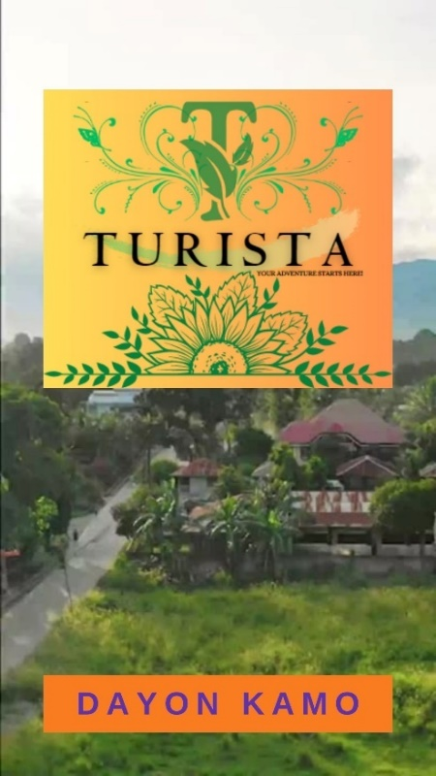The welcome turista portal or “**Dayon Kamo Portal**”, wherein the tourists/locals can click the “**Dayon Kamo**” button to proceed to the admin and turista users menu.

**ADMIN USER AND TURISTA USER MENU**

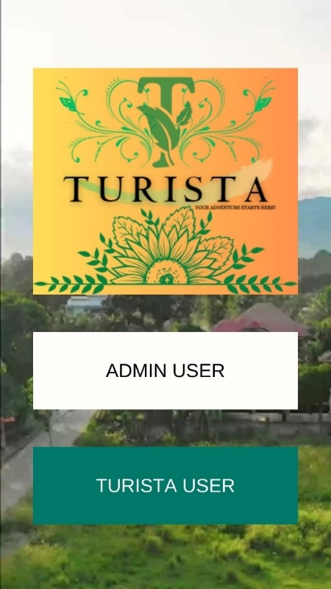

The Admin User and Turista User Menu, composed of:

**ADMIN USER:** wherein the admin only can view the list of tourist/local registered in the registration portal.

**TURISTA/LOCAL USERS:** wherein the Tourists or even locals can registered/login his/her username and password and it will proceed to the Turista Main Menu of the Turista Mobile App with different features or portals.

**FOR ADMIN USERS ONLY**

**ADMIN LOGIN FORM PORTAL**

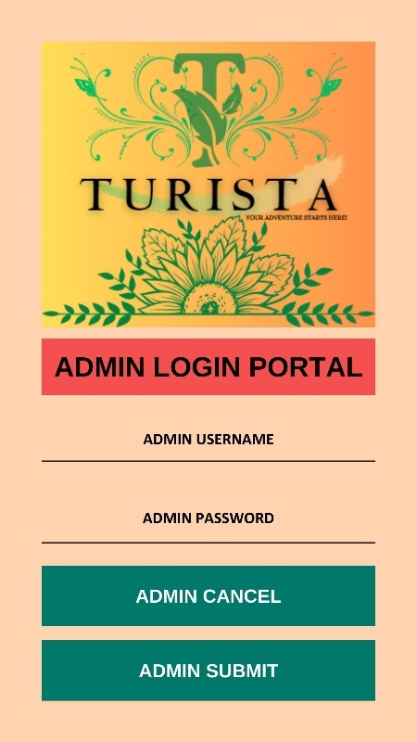The Admin Login Portal, consists of the admin username and password. The admin users only can view the list of tourists registered. Once the admin inputted the username and password, it will proceed to the admin menu portal.

The admin username: **admin**

The admin password: **admin123**

**ADMIN MENU PORTAL**

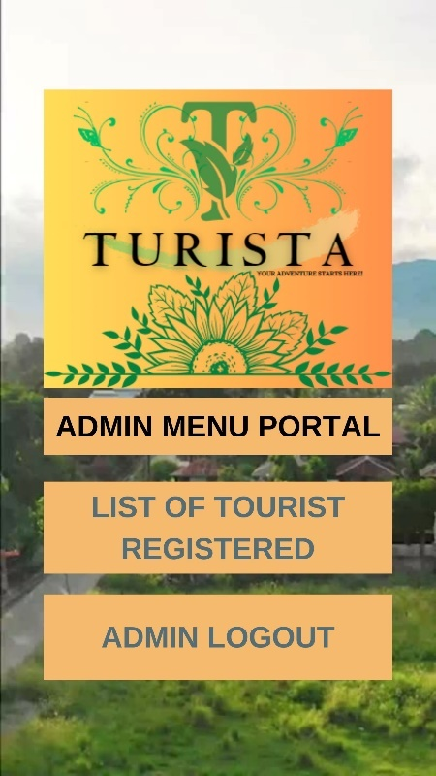This admin menu portal consists of :

The List of Tourist Registered: wherein the admin can view the inputted details of a certain tourists/locals in the list of tourists registered according to:

* **First name**
* **Last name**
* **Address**
* **Place of Origin**
* **Age**
* **Gender**
* **Turista Username**
* **Turista Password**
* **Turista Confirm Password**

The admin users can also logout the Admin Menu Portal by clicking the “Admin Logout” button and it will be returned to the Welcome Turista Portal (Dayon Kamo Portal).

**LIST OF TOURISTS REGISTERED**

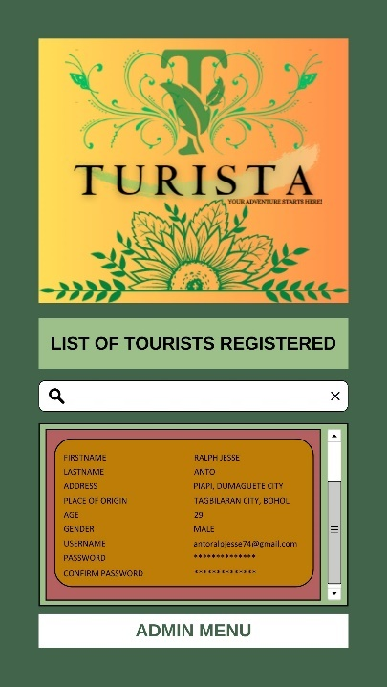This portal wherein you can search and view all the list that are being registered. You can search the first name or even the last name of the locals/tourists that is being listed and registered.

The admin user can only search and view all the list in the tourists registered portal. The admin also can click the Admin Menu button to go back to the admin menu portal.

**FOR LOCALS AND TOURISTS USERS ONLY**

**TURISTA LOGIN FORM PORTAL**

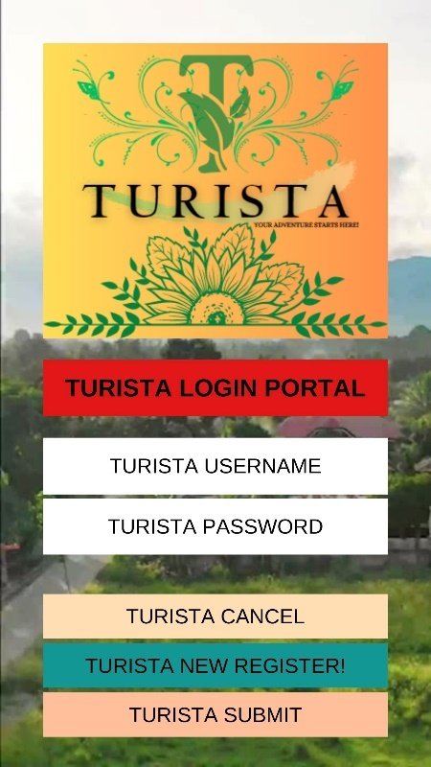In the Admin Users and Turista Users Menu Portal, for locals and tourists users only, you can click the “**TURISTA USERS**” button. Once you’ve click the “**TURISTA USERS**” button, it will automatically proceed to the Turista Login Form Portal. If you have already registered in this account and completely finished all the login information details like the username and password, click “**TURISTA SUBMIT**” button to submit and it will be proceed to the **TURISTA MAIN MENU.** If you are a new turista user, click the “**TURISTA NEW REGISTER**” button to proceed to the **TURISTA REGISTRATION PORTAL.**

You can also click the “**TURISTA CANCEL**” button to go to the Admin Users and Turista Users Menu Portal.

**TURISTA REGISTRATION FORM PORTAL**

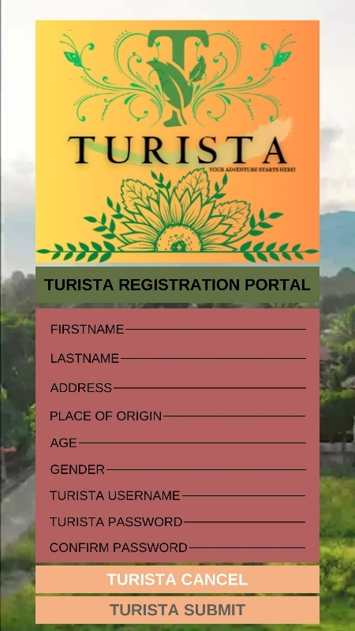In the Turista Registration Form Portal, wherein the new user can fill-out all the information details are as follows:

* **First name**
* **Last name**
* **Address**
* **Place of Origin**
* **Age**
* **Gender**
* **Turista Username**
* **Turista Password**
* **Turista Confirmation Password**

Once you’ve fill-up, validate and confirm all the information details, click the “**TURISTA SUBMIT**” button and it will go back to the Turista Login Form Portal. Also, you can also click “**TURISTA CANCEL**” button if you have already registered in the registration form.

**TURISTA MAIN MENU PORTALS**

**TURISTA MAIN MENU PORTAL**

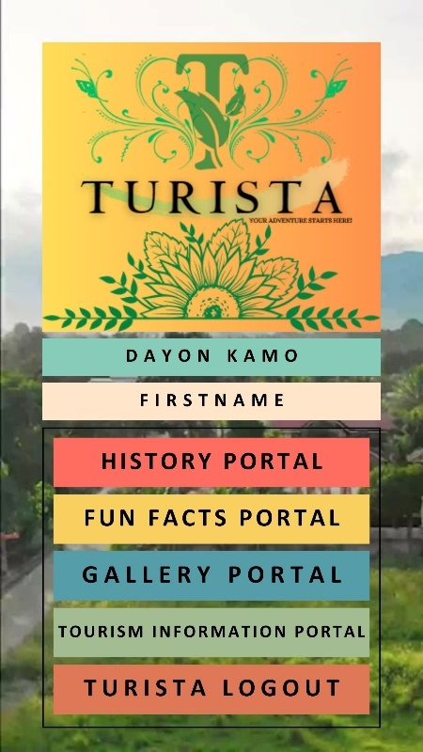In the Turista Main Menu Portal, it consists of the following features or portals:

* **History Portal / History Menu Portal**
* **Fun Facts Portal**
* **Gallery Portal / Gallery Menu Portal**
* **Tourism Information Portal**

Once you’ve login all the information details in the Turista Login Form Portal, it will automatically view the first name once you logged in the Turista Login Form Portal. Once you’ve finished view and even search all the features or portals. You can click “**TURISTA LOGOUT**” button for exit and it will automatically proceed to Welcome Turista Portal.

**HISTORY PORTAL**

**HISTORY MENU PORTAL**

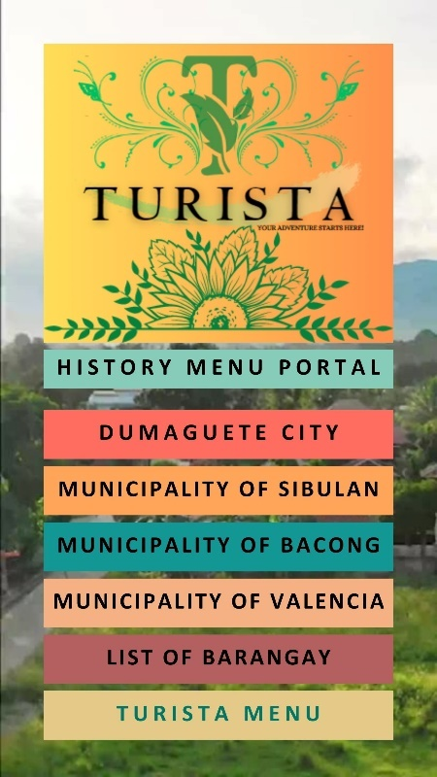The History Menu consists of one main city and three municipalities with their history:

* **DUMAGUETE CITY**
* **MUNICIPALITY OF SIBULAN**
* **MUNICIPALITY OF BACONG**
* **MUNICIPALITY OF VALENCIA**

Also, the tourists can click once you’ve view all the history, you can click the “**List of Barangay**” button to view all the places with their corresponding barangays. You can click the turista menu and it goes back to the Turista Main Menu.

**HISTORY ONE:DUMAGUETE CITY**

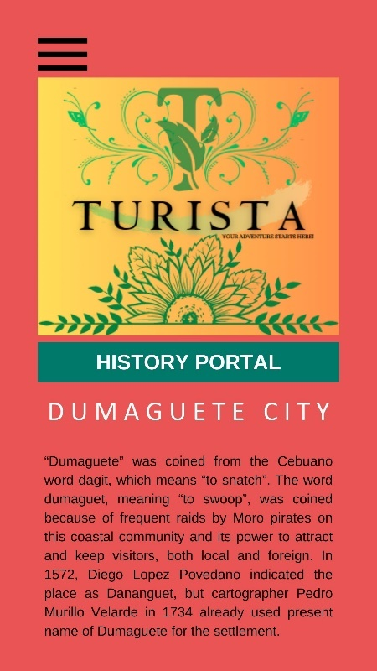The History one or so-called the History of Dumaguete City. It consists of the history of Dumaguete City. You can click the  (menu button) and it goes back to the History Menu Portal.

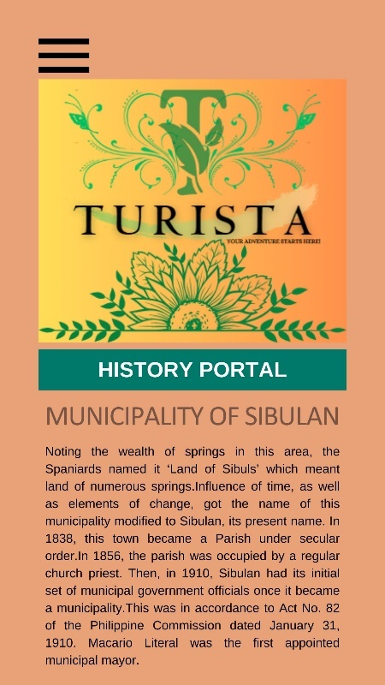**HISTORY TWO: THE MUNICIPALITY OF SIBULAN**

The History two or so-called the History of the Municipality of Sibulan. It consists of the history of Municipality of Sibulan. You can click the  (menu button) and it goes back to the History Menu Portal.

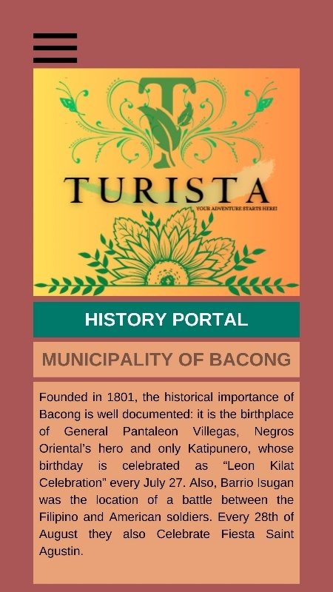**HISTORY THREE: MUNICIPALITY OF BACONG**

The History three or so-called the History of the Municipality of Bacong. It consists of the history of Municipality of Bacong. You can click the  (menu button) and it goes back to the History Menu Portal.

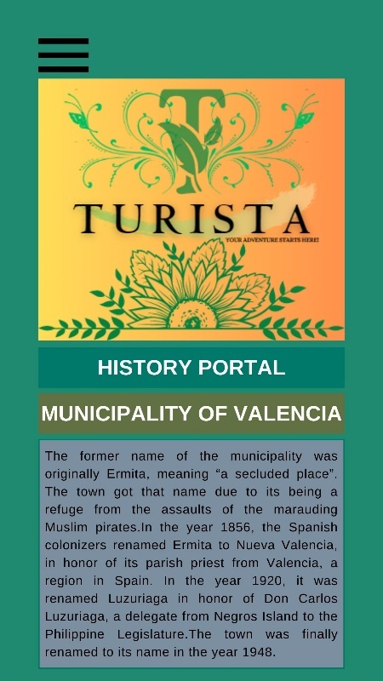**HISTORY FOUR: MUNICIPALITY OF VALENCIA**

The History four or so-called the History of the Municipality of Valencia. It consists of the history of Municipality of Valencia. You can click the  (menu button) and it goes back to the History Menu Portal.

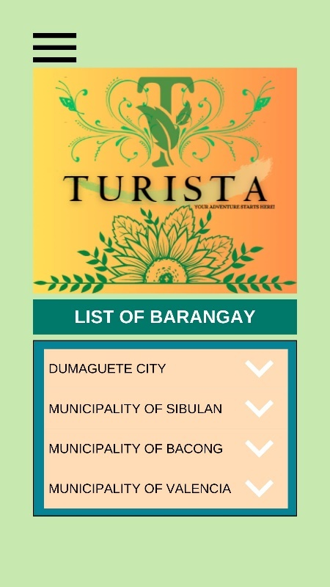**LIST OF BARANGAYS**

In the List of Barangays, the tourists can view every city or municipalities with their corresponding barangays. You can click the  (menu button) and it goes back to the History Menu Portal.

* **Dumaguete City ( 30 barangays)**
* **Municipality of Sibulan ( 15 barangays)**
* **Municipality of Bacong ( 22 barangays)**
* **Municipality of Valencia ( 24 barangays)**

**FUN FACTS PORTAL**

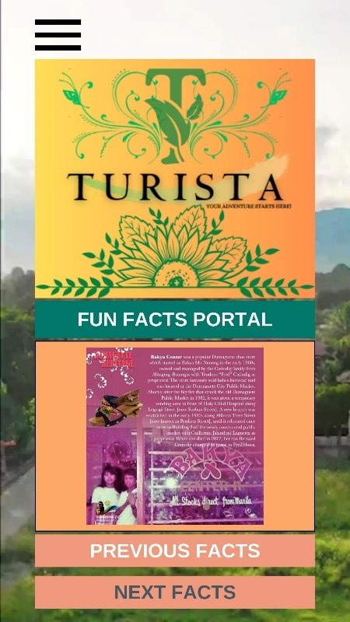The Fun Facts portal consists of the different facts about personalities, history and culture, places, food and many more. You can also click the “**PREVIOUS FACTS AND NEXT FACTS**” button for change photos and to view photos. You can click the  (menu button) and it goes back to the Turista Main Menu.

**GALLERY MENU PORTAL**

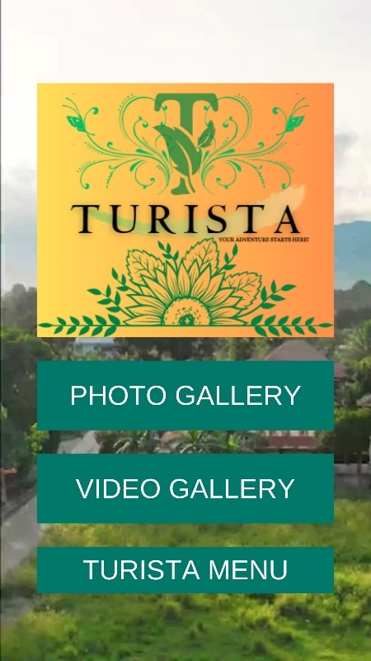The Gallery Menu Portal consists of the photo gallery and the video gallery. You can also click the Turista Menu and it goes back to the Turista Main Menu.

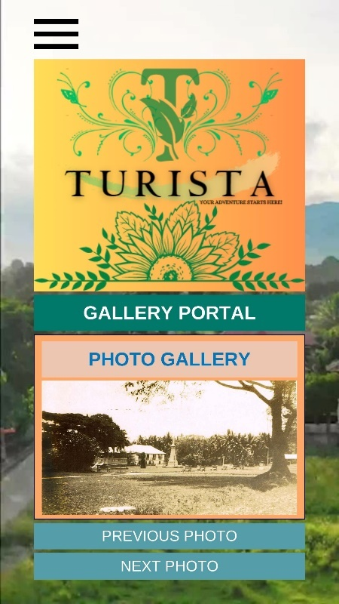**PHOTO GALLERY PORTAL**

The Photo Gallery Portal wherein you can view all the photos by clicking the “**PREVIOUS AND NEXT PHOTO**” button to change another photo. It includes the old photo of Dumaguete City. You can click the  (menu button) and it goes back to the Gallery Menu.

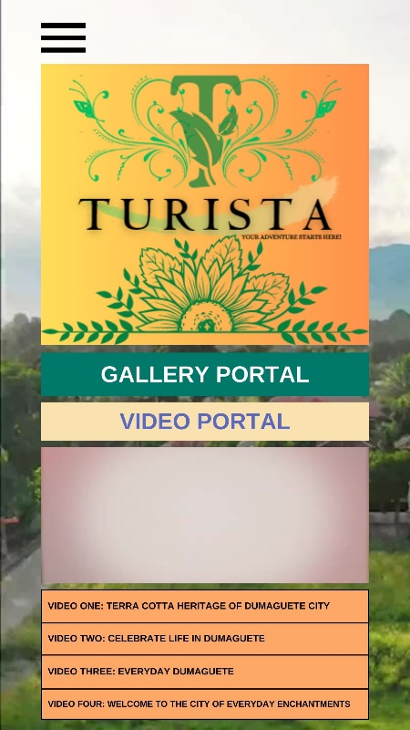**VIDEO GALLERY PORTAL**

The Video Gallery Portal contains the different videos about Metro Dumaguete. You can click any videos you want to play in videos gallery portal. You can click the  (menu button) and it goes back to the Gallery Portal.

**TOURISM INFORMATION PORTAL**

**TOURISM INFORMATION MENU PORTAL**

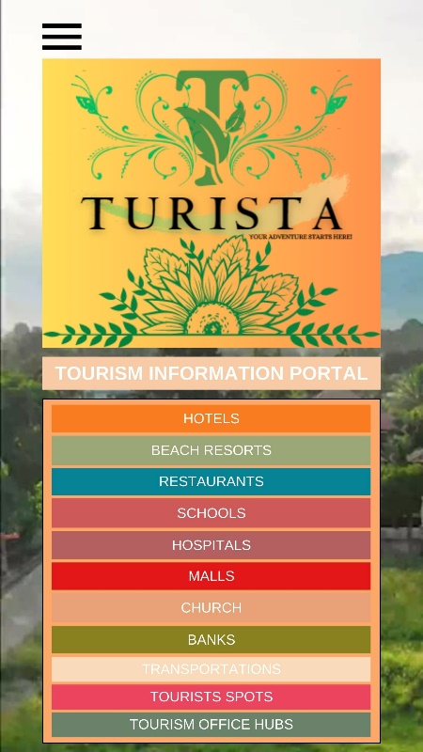The Tourism Information Menu Portal contains of the following legends or category per color coding. You can click the  (menu button) and it goes back to the Turista Main Menu.

* Hotels
* Beach Resorts
* Restaurants
* Schools
* Hospitals
* Malls
* Church
* Banks
* Transportation
* Tourists Spots
* Tourism Office Hubs

The information details being viewed in the Tourism Information Portal are as follows:

* Photo of an establishment per category
* Name
* Address
* Contact number
* URL Link
* Navigation Map

|  |  |  |
| --- | --- | --- |
| **TOURISM INFORMATION PORTAL (per category)** | | |
| TOURISM INFORMATION ONE | **HOTEL** |  |
| TOURISM INFORMATION TWO | **BEACH RESORTS** |  |
| TOURISM INFORMATION THREE | **RESTAURANTS** |  |
| TOURISM INFORMATION FOUR | **SCHOOLS** |  |
| TOURISM INFORMATION FIVE | **HOSPITALS** |  |
| TOURISM INFORMATION SIX | **MALLS** |  |
| TOURISM INFORMATION SEVEN | **CHURCH** |  |
| TOURISM INFORMATION EIGHT | **BANKS** |  |
| TOURISM INFORMATION NINE | **TRANSPORTATION** |  |
| TOURISM INFORMATION TEN | **TOURISTS SPOTS** |  |
| TOURISM INFORMATION ELEVEN | **TOURISM OFFICE HUBS** |  |

**TOURISM INFORMATION PORTAL ONE**

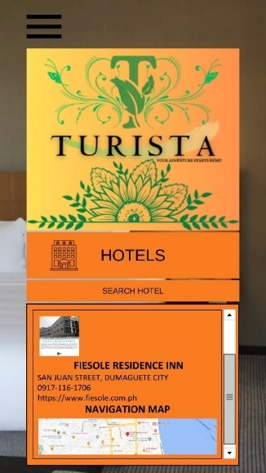(HOTELS)

This is the Tourism Information Portal One: Hotel, the tourists or even locals can search the name of a hotel establishment and it will automatically view all the information details about a certain establishment. You can click the  (menu button) and it goes back to the Tourism Information Menu Portal.

**TOURISM INFORMATION PORTAL TWO**

(BEACH RESORTS)

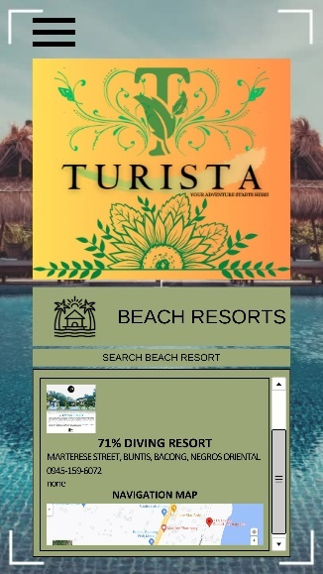This tourism information portal contains the information details of beach resorts in Metro Dumaguete. You can search the name of a resort and it will automatically view all the details in resort information list. You can click the  (menu button) and it goes back to the Tourism Information Menu Portal.

**TOURISM INFORMATION PORTAL THREE**

(RESTAURANTS)

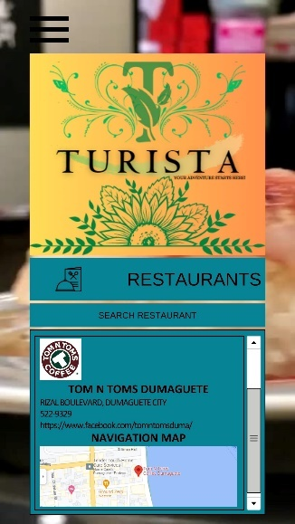This portal contains the information details of a restaurant. You can search the name of an establishment and it can view all the information details about a certain restaurant in the information list. You can click the  (menu button) and it goes back to the Tourism Information Menu Portal.

**TOURISM INFORMATION PORTAL FOUR**

(SCHOOLS)

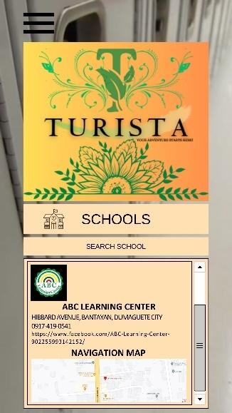This portal contains the information details of a school. You can search the name of a school and it can view all the information details in the school information list. You can click the  (menu button) and it goes back to the Tourism Information Menu Portal.

**TOURISM INFORMATION PORTAL FIVE**

(HOSPITALS)

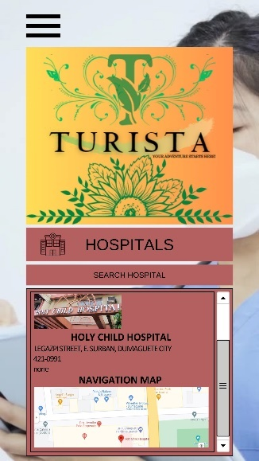This portal contains the information details of a hospital. You can search the name of a hospital and it can view all the details. You can click the  (menu button) and it goes back to the Tourism Information Menu Portal.

**TOURISM INFORMATION PORTAL SIX**

(MALLS)

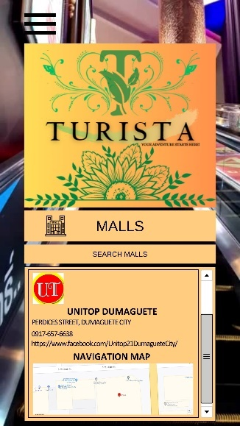This portal contains the information details of mall. You can search the name of mall establishment and it will view all the information details like the name, address, contact number, the URL link and the navigation map. You can click the link that will transfer to the social media platform for more details. You can click the  (menu button) and it goes back to the Tourism Information Menu Portal.

**TOURISM INFORMATION PORTAL SEVEN**  
(CHURCH)

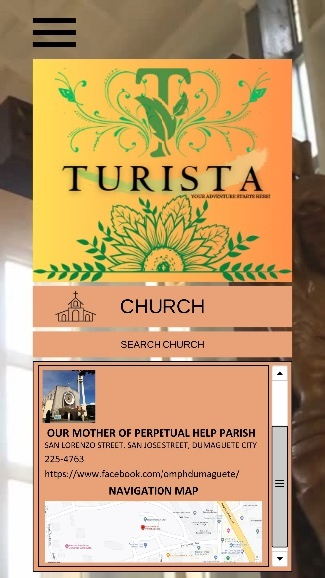This portal contains the church information details. You can search the name of the church and it will view all the info details. You can click the link that will transfer to the social media platform for more details. You can click the  (menu button) and it goes back to the Tourism Information Menu Portal.

**TOURISM INFORMATION PORTAL EIGHT**

(BANKS)

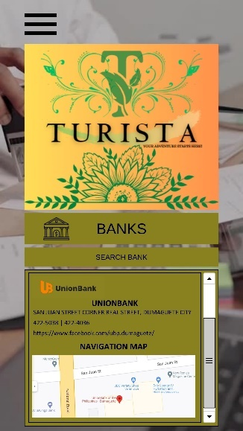This portal contains the bank information details. You can search the name of the bank and it will view all the info details. You can click the link that will transfer to the social media platform for more details. You can click the  (menu button) and it goes back to the Tourism Information Menu Portal.

**TOURISM INFORMATION PORTAL NINE**  
(TRANSPORTATIONS)

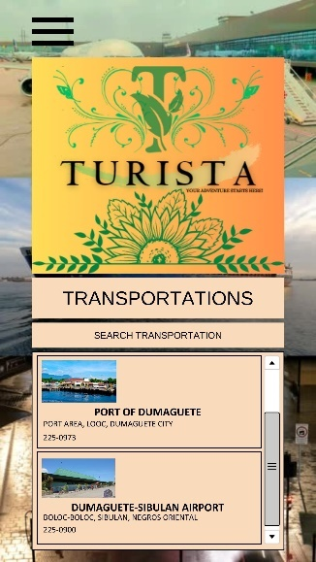This portal contains the transportation information. You can search the name of the transportation and it will view all the information details. You can click the  (menu button) and it goes back to the Tourism Information Menu Portal.

**TOURISM INFORMATION PORTAL TEN**

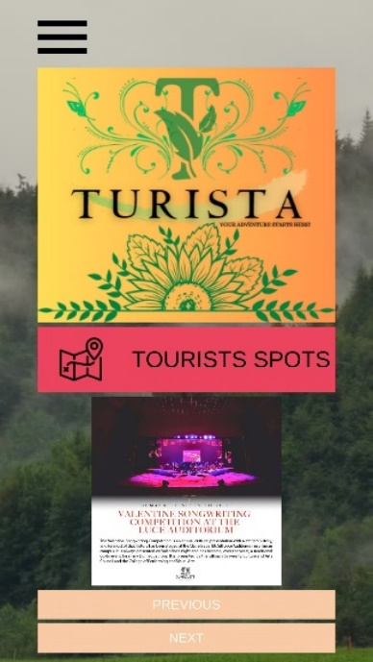(TOURISTS SPOTS)

This is the tourism information portal for tourists spots. It is a portal wherein you can find all the tourists spots here in Metro Dumaguete. It consists of the tourists spots are as follows:

* Dumaguete City
* Municipality of Sibulan
* Municipality of Bacong
* Municipality of Valencia

You can click the “**Previous and Next**” buttons for change photo to another. Every tourist spot has a name and the description. You can click the  (menu button) and it goes back to the Tourism Information Menu Portal.

**TOURISM INFORMATION PORTAL ELEVEN**

(TOURISM OFFICE HUBS)

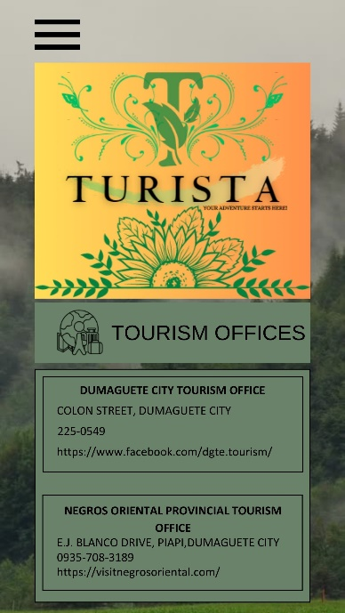This portal contains the tourism office information portal. You can view the information details. You can click the URL link for more information details. You can click the  (menu button) and it goes back to the Tourism Information Menu Portal.

**APPENDIX F**

**GANNT CHART**

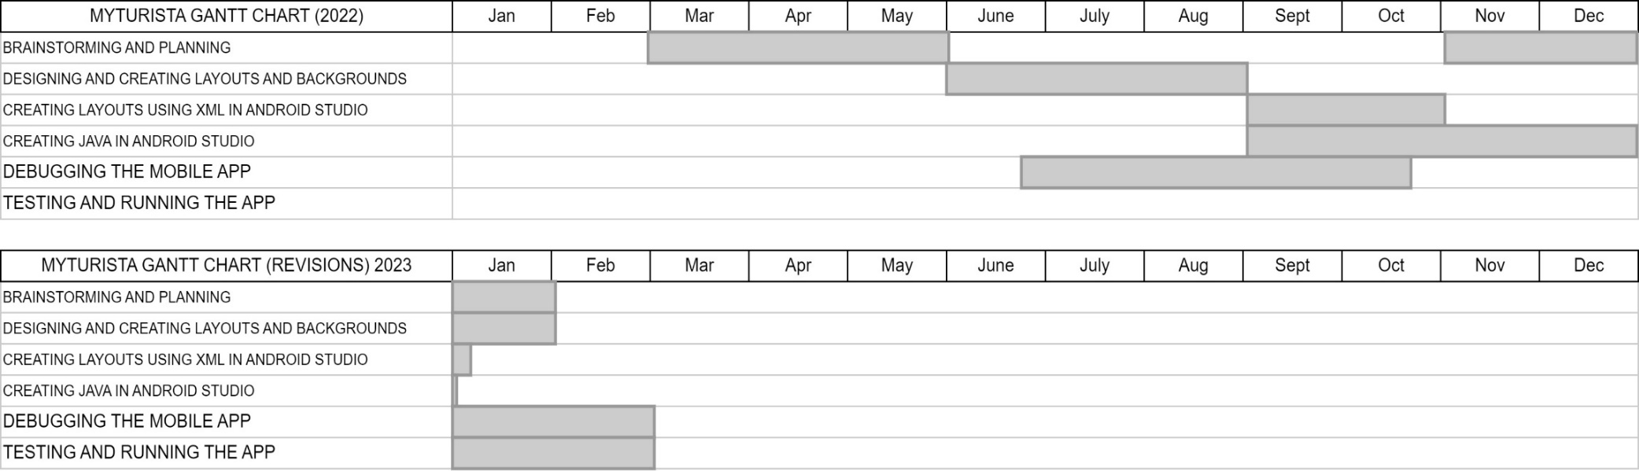

**APPENDIX G**

**CURRICULUM VITAE**

**ANTO, RALPH JESSE**

BACK OF NOPH, PIAPI, DUMAGUETE CITY

225-7700/09056168120

[jesseantoralp74@gmail.com](mailto:jesseantoralp74@gmail.com)

**CAREER OBJECTIVES**

* Looking forward to a challenging environment, where I can refine my skills and expand my knowledge for the dynamic growth of the organization.
* Seeking a challenging position and a lively work environment where I can grow personally and also contribute to the company’s growth using my excellent communication, technical and organizational skills.
* To become a successful professional in the field of Information Technology by utilizing my skills and enable further personal and professional development and work towards the prosperity of the organization

**PERSONAL INFORMATION**

**Birthdate:** October 9, 1993

**Age:** 29

**Civil Status:** Single

**Place of Birth:** Tagbilaran City, Bohol

**Sex:** Male

**Religion:** Roman Catholic

**Nationality:** Filipino

**EDUCATION ATTAINMENT**

**2010:** HIGH SCHOOL DEPARTMENT

SAINT PAUL UNIVERSITY DUMAGUETE

VETERANS AVENUE CORNER L. ROVIRA ROAD, DUMAGUETE CITY

**2014:** BACHELOR OF SCIENCE IN INFORMATION TECHNOLOGY

SAINT PAUL UNIVERSITY DUMAGUETE

VETERANS AVENUE CORNER L. ROVIRA ROAD, DUMAGUETE CITY

**2016-2020:** MASTERS OF SCIENCE IN INFORMATION TECHNOLOGY (ON-GOING)

NEGROS ORIENTAL STATE UNIVERSITY MAIN CAMPUS

KAGAWASAN AVENUE, DUMAGUETE CITY

**CERTIFICATIONS AND TRANINGS**

2021 Startup Thursday- Part 2: “Blockchain, Cryptocurrencies, and Decentralized Commerce”

Department of Information and Communications Technology

Visayas Cluster 2

June 10, 2021

DICT Cybersecurity Awareness Webinar 2020: How to be Cybersafe in this Pandemic

DICT Cybersecurity Bureau

May 01, 2020

A Quick Look on Industry 4.0

Department of Information and Communications Technology

Visayas Cluster 2

May 04, 2020

Free Webinar in Web Development Using WordPress and Government Web Template

Department of Information and Communications Technology

Visayas Cluster 2

May 08, 2020

Primer on Data Privacy Act

Department of Information and Communications Technology

Visayas Cluster 2

May 08, 2020

Communications Set-up Using IP Radio

Department of Information and Communications Technology

Visayas Cluster 2

May 12, 2020

Introduction to Micro Python

Department of Information and Communications Technology

Visayas Cluster 2

May 14, 2020

WIFI: The 6th Gen

Department of Information and Communications Technology

Visayas Cluster 2

May 18, 2020

Learn to Code: HTML for Beginners

Department of Information and Communications Technology

Visayas Cluster 2

May 19, 2020

Basic Computer Troubleshooting

Department of Information and Communications Technology

Visayas Cluster 2

May 20, 2020

Learn to Use: Google Drive

Department of Information and Communications Technology

Visayas Cluster 2

May 21, 2020

DICT Cybersecurity Awareness Webinar 2020: The Art of Cyber Deception: How to Learn and

Prevent Social Engineering Attacks

Department of Information and Communications Technology

Visayas Cluster 2

May 22, 2020

Information Security: Getting to know about real protection

Department of Information and Communications Technology

Visayas Cluster 2

May 25, 2020

Learn to Create: Google Forms for Beginners

Department of Information and Communications Technology

Visayas Cluster 2

May 27, 2020

Sensor Integration in Micro Python

Department of Information and Communications Technology

Visayas Cluster 2

May 28, 2020

DICT Cybersecurity Awareness Webinar 2020: Password Decoded: A Cybersecurity Awareness

Webinar on Password Security

DICT Cybersecurity Bureau

May 29, 2020

Get Paid Online, Work Offline

Department of Information and Communications Technology

Visayas Cluster 2

May 29, 2020

How to Reach your Message to your Audience with Video Marketing

Department of Information and Communications Technology

Visayas Cluster 2

June 02, 2020

3rd Micro Python Series: Internet of Things

Department of Information and Communications Technology

Visayas Cluster 2

June 04, 2020

Facebook Marketing 101

Department of Information and Communications Technology

Visayas Cluster 2

June 05, 2020

Graphics Design 101

Department of Information and Communications Technology

Visayas Cluster 2

June 09, 2020

Machine Learning

Department of Information and Communications Technology

Visayas Cluster 2

June 15, 2020

App and Website Design Using Figma for UI/UX

Department of Information and Communications Technology

Visayas Cluster 2

June 17, 2020

Micro Python Series #4: Intermediate Python and the Micro Python Runtime Environment

Department of Information and Communications Technology

Visayas Cluster 2

June 18, 2020

Segment 1: Realities of Cyberspace

DICT Cybersecurity Bureau

June 24, 2020

Segment 2: Cybertalk with CERT-PH

DICT Cybersecurity Bureau

June 24, 2020

Segment 3: PKI and its Role in the New Normal

DICT Cybersecurity Bureau

June 24, 2020

Structured Cabling 101

Department of Information and Communications Technology

Visayas Cluster 2

June 24, 2020

Micro Python Series #5: Object-oriented Programming in Micro Python

Department of Information and Communications Technology

Visayas Cluster

June 25, 2020

Cyber Safety and Secure Online Shopping Webinar

Department of Information and Communications Technology

Visayas Cluster 2

June 25, 2020

Mobile Photography Basics

Department of Information and Communications Technology

Visayas Cluster 2

June 26, 2020

Introduction to Artificial Intelligence

Department of Information and Communications Technology

Visayas Cluster 2

June 30, 2020

Arm Yourself against Cyberattacks

Department of Information and Communications Technology

Visayas Cluster 2

July 02, 2020

Career Opportunities in the Game Development and Animation Sector: Online IT-BPM Industry

Career Roadshows

Department of Information and Communications Technology

Visayas Cluster 2

July 02, 2020

Data Protection for you and your Business: What you need to know

Department of Information and Communications Technology

Visayas Cluster 2

July 03, 2020

Network 101 and How Security Monitoring Works: Increased Importance of Visibility for

NetSecOps

Department of Information and Communications Technology

Visayas Cluster 2

July 15, 2020

Having the Right Mindset for Online Freelancers amidst the Pandemic Crisis

Department of Information and Communications Technology

Visayas Cluster 2

July 17, 2020

**WORK EXPERIENCE**

**On-the-Job Training in Philippine Statistics Office (National Statistics Office)**

Jose Romero Road, Bagacay, Dumaguete City

April to May 2015

**SKILLS AND ABILITIES**

**LANGUAGE:** English, Tagalog

**COMMUNICATION:** Comfortable writing and speaking

**TIME MANAGEMENT**

**COMPUTER LITERACY:** Proficient in MS Word, PowerPoint, Excel and Access

Proficient in Adobe Dreamweaver, Canva, Adobe XD, Android Studio

Proficient in Programming Language: C++, Java, PHP, CSS